Hinsdale County House Marker Sign Project
Spring 2021
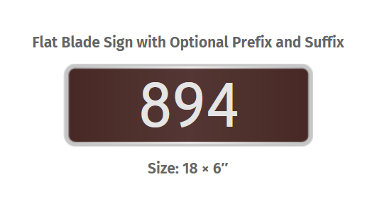
Property Owner’s Name: ________________________________________
Property Owner’s Address: ______________________________________ (Hinsdale County)
Property Owner’s Phone Number: __________________________________
Property Owner’s Email Address: _______________________________________

Property Number to be placed on sign: ________________________
Quantity of signs: __________________
1 sign = $34.00 2-3 signs = $33.00 each 4 signs = $32.00 each

Amount enclosed: $______________________________

Return form and payment to Hinsdale County, Attn House Sign Project, PO Box 277, Lake City, CO 81235

Orders must be received by MAY 15th, 2021, to be included in the first order

Questions? Commissioner Kristie Borchers district2@hinsdalecountycolorado.us
Emergency Manager Phil Graham em@hinsdalecountycolorado.us

Hinsdale County will be purchasing these replacement signs:
