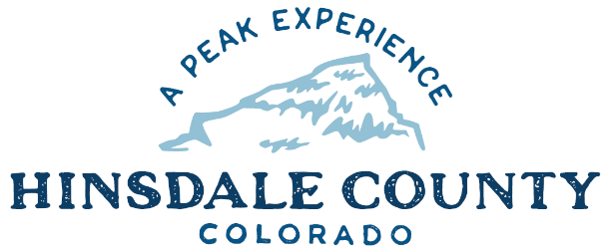
+
HINSDALE COUNTY

BOARD OF COUNTY COMMISSIONERS
Wednesday, May 24, 2023 – 8:30 a.m.

SPECIAL WORKSHOP
Coursey Annex, 311 Henson Street, Lake City

8:30 am WORKSHOP

- Discussion with Ash Reynolds Regarding County Operations Building Design

CLOSE WORKSHOP

ADJOURN

To attend meeting virtually using GoToMeeting:
https://meet.goto.com/897529637
You can also dial in using your phone.
(872) 240-3311
Access Code: 897-529-637

