Wheeler Road #600

# Further Information

Forest Service

U.S. DEPARTMENT OF AGRICULTURE

**Where:** Forest Road 600 is closed at Hanson’s Mill. Forest Road 600.3A is closed prior to the junction with Forest Road 600 at Divide Park.

**What:** The Roads are closed to all motorized vehicles. Options for accessing Wheeler include hiking the Wheeler Trail #790 (7.75 miles one way, 1676 ft elevation gain) or mountain biking the road in and then hiking into the Geologic Area (13.5 miles one way, 1600 ft elevation gain). The hiking trail enters Wilderness and bikes are not allowed. E- bikes are not permitted on the road or trail as they are classified as a motorized vehicle. Camping is prohibited within the Wheeler Geologic Area.

**Why:** Heavy storms during 2022 produced floods that washed out and eroded the road. The road is closed for public safety and to prevent further resource damage.

**When:** Work is anticipated to begin in June

once the road dries out.

**Who:** The Rio Grande National Forest is responsible for maintaining the road and will complete the work needed. Contact the Divide Ranger District with questions.

# Alternative Locations

**Bristol Head:** Forest Road 532 requires a high

clearance 4x4 vehicle.

**Park Creek to Summitville:** Forest Road 380 provides a scenic drive to Summitville and is accessible by passenger car.

**Carson:** Visit the ghost town of Carson on Forest Road

568. It is accessed from the Lake City area. This road requires a high clearance 4x4 vehicle.

**Stony Pass:** Driving up to the pass requires a high clearance 4x4 vehicle.

**Bachelor Loop:** Drive the scenic interpretive loop located north of Creede. All wheel drive recommended.

**Rio Grande National Forest Special Orders** Roads are closed by

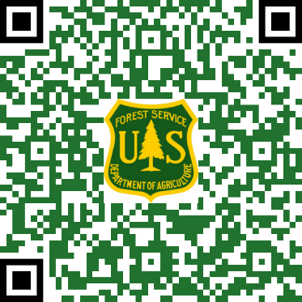special orders. To view all Special Orders currently on the Rio Grande National Forest, visit: [*www.fs.usda.gov/goto/*](http://www.fs.usda.gov/goto/) *riogrande/specialorders*



## Respect the safety of workers and others by keeping out of closed areas and giving crews space to

*do their work.*

# Contact Us

**Divide Ranger District** 13308 W Hwy 160

Del Norte, CO 81132 719-657-3321

[www.fs.usda.gov/riogrande](http://www.fs.usda.gov/riogrande)

Facebook: U.S. Forest Service—Rio Grande National Forest

**Colorado Parks and Wildlife** 719-587-6900

USDA is an equal opportunity provider,

employer, and lender.

**Divide Ranger District**

Closures and Maintenance 2023

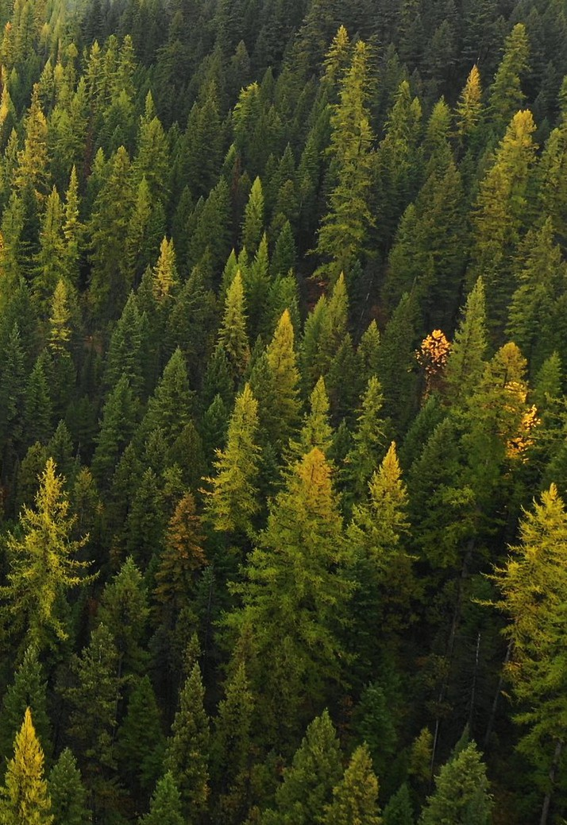

Rio Grande



# Continental Bridge Rito Hondo Reservoir Million Reservoir

**Where:** The Rio Grande National Forest has closed the bridge on Forest Road 513.1A to Continental Reservoir to all passenger vehicles.

**What:** The bridge will be open to foot, bike, ATV, and side-by-side traffic 62 inches or less in width at the widest point. Park in the Rito Hondo area to unload OHVs. While work is being done the bridge and surrounding area will be entirely closed to the public.

**Why:** The bridge needs to be replaced so it can safely accommodate the weight of vehicles.

**When:** Work replacing the bridge is anticipated to begin in August 2023.

**Who:** The Rio Grande National Forest is responsible for maintaining the bridge and road. The repair and replacement work will be done by Forest engineers and the heavy maintenance and road crews. Contact the Divide District with further questions.

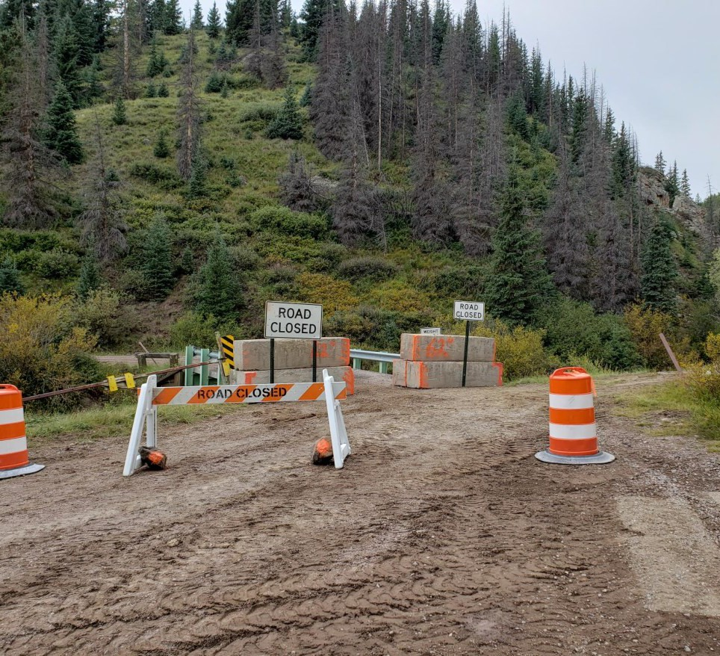

**Where:** The Rio Hondo Reservoir is located on Forest Road 513 and has been drained for the last few years.

**What:** Work will begin on the reservoir dam.

**Why:** Repairs are needed to address seepage through the dam.

**When:** Colorado Parks and Wildlife is anticipating work will begin in mid-May 2023.

**Who:** The Reservoir is located on the Forest but is maintained and managed by Colorado Parks and Wildlife (CPW). Contact CPW with further questions.



# Alberta Reservoir

**Where:** The Alberta Reservoir is located near Wolf Creek Pass and has been drained for the last several years. It is located off of Forest Road 291.

**What:** Work will begin on the reservoir dam

this summer.

**Why:** Repairs are needed to address dam safety concerns.

**When:** Colorado Parks and Wildlife is anticipating work will begin in June 2023.

**Who:** The Reservoir is located on the Forest but is maintained and managed by Colorado Parks and Wildlife. Contact CPW with further questions.

**Where:** Million Reservoir is located near Beaver Creek Reservoir on Forest Road 360.4b.

**What:** The Reservoir will be drained and then repair/maintenance work will be done on the dam.

**Why:** Repairs are needed to address the spillway and logs gathering at the outlet.

**When:** The Reservoir will begin to be drained in May and work is anticipated to begin in June 2023.

**Who:** The Bureau of Reclamation will be conducting the work on the reservoir in partnership with the Rio Grande National Forest and Colorado Parks and Wildlife. Contact the Divide District with further questions.

# Alternative Locations

**Beaver Creek Reservoir:** Located along Forest Road 360, this reservoir has a boat ramp and is stocked by CPW.

**Rio Grande Reservoir and Road Canyon Reservoir**: Both reservoirs are located along Forest Road 520. Road Canyon Reservoir is stocked by CPW.

**Lake San Cristobal:** Located near Lake City this lake provides many recreation opportunities.

**Big Meadows and Shaw Reservoirs:** Both reservoirs are located along Forest Road 430 and have fishing access trails along the shores. Big Meadows Reservoir has a boat ramp and is stocked by CPW.