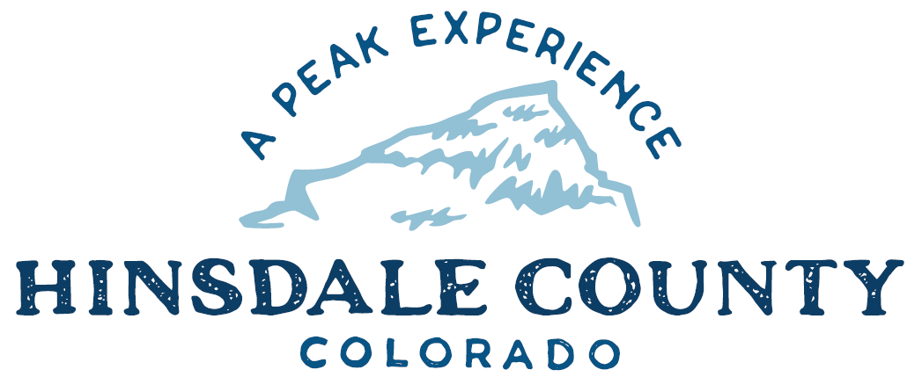

BOARD OF COUNTY COMMISSIONERS
WORKSHOP & MEETING
Coursey Annex, 311 N. Henson St., Lake City

Wednesday, October 20, 2021 – 8 a.m.
AGENDA

Register in advance for this meeting:

https://us02web.zoom.us/meeting/register/tZEkcumvpzorHdOVZM4fFANinjCXRbAor_v-

After registering, you will receive a confirmation email containing information about joining the meeting.

Technical difficulties may occur during the meeting due to network limitations.

8 AM OPEN DISCUSSION

8:30 AM WORKSHOP

- Discuss Professional Services Agreement with Ayers Associates for Brownfields Assessment Project
- Discuss Letter to Forest Service on Workforce Housing Project
- Discuss Transfer Station Updated Price list
- Discuss Update on Reducing Wildfire Risk in Hinsdale County
- Discuss End Date of Wildfire Mitigation Debris Incentive Program
- Discuss Resolution Amending Boat Slip Policy
- Discuss Grants Path
- Discuss Department of Local Affairs (DOLA) Administration Grant Request for Asset Inventory
- Discuss December Commissioner Meetings
- Discuss Process to Sell County Properties
- Discuss Capitol City Properties
- Discuss SO/Admin Building Project
- Discuss Ratification of State of Colorado Body Cam Funding for Sheriff’s Office
- Discuss Assessor’s Annual Audit Report
- Discuss Letter of Support for Application of Commissioner Borchers to Resource Advisory Council (RAC) for Bureau of Land Management (BLM) Colorado’s Southwest District

CLOSE COMMISSIONER WORKSHOP

10 AM OPEN COMMISSIONER’S REGULAR MEETING

Pledge of Allegiance
Modifications to the Agenda
Approval of the Agenda

CITIZEN COMMENTS FROM THE FLOOR

REGULAR AGENDA

- Consider Professional Services Agreement with Ayers Associates for Brownfields Assessment Project
- Consider Letter to Forest Service on Workforce Housing Project
- Consider Transfer Station Updated Price list
- Consider End Date of Wildfire Mitigation Debris Incentive Program
- Consider Boat Slip Lottery policy
- Consider DOLA Administration Grant Request for Asset Inventory
- Consider Ratification of State of Colorado Body Cam Funding for Sheriff’s Office
- Consider Letter of Support for Commissioner Borchers Application to BLM RAC Colorado’s Southwest District

ANY UNSCHEDULED BUSINESS
PRESENTATION OF BILLS TO BE PAID

ADJOURN MEETING

BUDGET WORKSHOP #2

Times stated are approximate and the agenda may be modified as necessary at the discretion of the Board. The next Commissioner’s meeting is a workshop and meeting scheduled for Wednesday, November 3, 2021, unless otherwise noted at the Coursey Annex, 311 N. Henson Street, Lake City, CO 81235.

Two or more Hinsdale County Commissioners may attend the Town of Lake City Board of Trustees Meeting on Wednesday, October 20, at 6 p.m.

