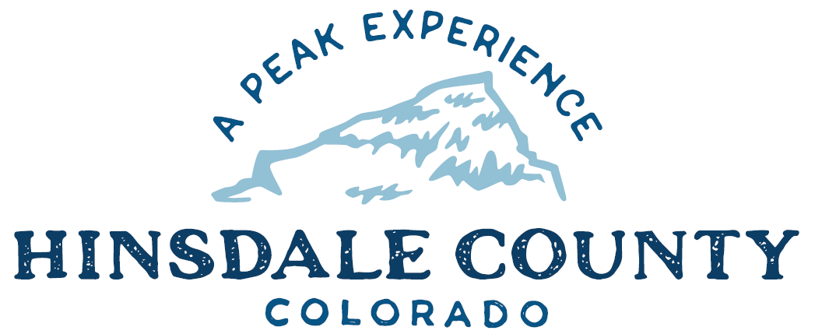

BOARD OF COUNTY COMMISSIONERS
WORKSHOP & MEETING
Coursey Annex, 311 N. Henson St., Lake City

Wednesday, January 26, 2022 – 8 a.m.
AGENDA

Register in advance for this meeting:
https://us02web.zoom.us/meeting/register/tZMpf-CqqjMuHNPnzFpBnIclDg8hRMr5rhhN

After registering, you will receive a confirmation email containing information about joining the meeting.
Technical difficulties may occur during the meeting due to network limitations.

8 AM OPEN DISCUSSION

8:30 AM WORKSHOP

- Discuss 2022 County Goals/2021 County Accomplishments
- Discuss Main Street Mini-Grant Town Park Project
- Discuss Colorado Department of Transportation (CDOT) Revitalizing Main Street grant application
- Discuss Seller’s Property Disclosure for Wee Care Property
- Discuss Sales Agreement with Wagner for Cat CS56B Compactor
- Discuss Proposed Senate Bill 22-031, Prohibit Hunting Bobcat, Lynx and Mountain Lion
- Discuss Special Events Liquor Permit for Chamber of Commerce Brewski Event, February 12, 2022

CLOSE COMMISSIONER WORKSHOP

10 AM OPEN COMMISSIONER’S REGULAR MEETING

Pledge of Allegiance
Modifications to the Agenda
Approval of the Agenda

10:05 AM PUBLIC HEARING – To receive comments on a Special Events Liquor Permit for Lake City/Hinsdale County Chamber of Commerce Lake San Cristobal Brew-Ski Event

CITIZEN COMMENTS FROM THE FLOOR

REGULAR AGENDA

- Consider 2022 County Goals
- Consider Main Street Mini-Grant Town Park Project
- Consider CDOT Revitalizing Main Street grant application
- Consider Seller’s Property Disclosure for Wee Care Property
- Consider Sales Agreement with Wagner for Cat CS56B Compactor
- Consider Special Events Liquor Permit for Chamber of Commerce Brewski Event, February 12, 2022

ANY UNSCHEDULED BUSINESS
PRESENTATION OF BILLS TO BE PAID

ADJOURN MEETING

Times stated are approximate and the agenda may be modified as necessary at the discretion of the Board. The next Commissioner’s meeting is a workshop and meeting scheduled for Wednesday, February 2, 2022, unless otherwise noted at the Coursey Annex, 311 N. Henson Street, Lake City, CO 81235.

