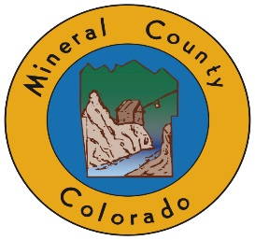
HINSDALE/MINERAL COUNTY COMBINED COMMISSIONERS
MEETING WEDNESDAY, SEPTEMBER 18, 2019, 10 AM
FREEMON’S RANCH, 39284 Hwy 149, CREEDE, CO 81130
10:00 AM Welcome—Commissioner(s) from each Board
10:10 AM Open to Public for comments or questions (2 mins. per person)

10:25 AM Continental Dam and Spillway Project Update – Jay Yeager, Superintendent of Santa Maria Reservoir Company

10:35 AM Colorado Parks and Wildlife Update — Brent Woodward, District Wildlife Manager
10:45 AM Rio Grande National Forest / Divide Ranger District Update – Tom Malecek, Deputy Forest Supervisor, and Martha Williamson, Divide District Ranger
11:00 AM Rocky Mountain Restoration Initiative — Travis Smith, National Wild Turkey Federation, Western Water Conservation Coordinator

11:10 AM San Luis Valley Irrigation District Update on Rio Grande Reservoir — Robert Phillips, Superintendent
11:20 AM Silver Thread Public Health District Update —Tara Hardy, Director

11:30 AM Road Update — JoAllen Blowers, Hinsdale County Road Supervisor, and Dannie Rogers, Mineral County Road Supervisor
11:45 AM Law Enforcement Update — Justin Casey, Hinsdale County Sheriff, and Fred Hosselkus, Mineral County Sheriff
12:00 PM Sandra Wagner, Lost Trail Station—Forest Service Road 520 Historic Sign Project

12:10 PM 30-Mile Resort Update – Concessionaires Tom and Erica Roden
12:25 PM Legislative Updates – Ms. Ann McCoy Harold, Office of Senator Cory Gardner; Erin Minks, Office of Senator Michael Bennet; Brenda Felmlee, Office of Representative Scott Tipton

1:00 PM ADJOURN (lunch provided by Hinsdale County from Freemon’s General Store)
Times stated are approximate and the agenda may be modified as necessary at the discretion of the Board. The next Commissioner’s meetings are: Hinsdale County 10/2/19 and Mineral County 10/7/19.

