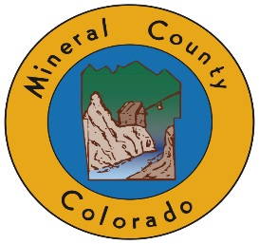

HINSDALE/MINERAL COUNTY COMBINED COMMISSIONERS MEETING WEDNESDAY, AUGUST 15, 2018 10 AM
FREEMONS RANCH, 39284 Hwy 149, CREEDE, CO 81130
10 AM — Welcome, Chair of each Board
10:15 AM -Open to Public for comments or questions (3 min per person)

10:30 AM -Colorado Parks and Wildlife Update — Brent Woodward, District Wildlife Manager
10:45 AM - Divide Ranger District Update - TBA
11:00 AM - RWEACT Update — Travis Smith

11:15 AM -San Luis Valley Irrigation Update on Rio Grande Reservoir — Robert Phillips
11:30 AM -Silverthread Public Health District Update —Tara Hardy

11:45 AM Road Update — Monte Hannah, Hinsdale County Road Supervisor, Dannie Rogers, Mineral County Road
12:00 PM — Supervisor Law Enforcement Update — Ron Bruce, Hinsdale County Sheriff, Fred Hosselkus Mineral County
12:15 PM — Sheriff Emergency Management Update —Jerry Gray, Hinsdale County Emergency Manager, Terry Wetherill Mineral County Emergency Manager

12:30 PM — Wilderness Discussion including both Boards
12:45 PM — Adjourn and lunch provided by Freemons General Store
Times stated are approximate and the agenda may be modified as necessary at the discretion of the Board. The next Commissioner’s meeting is a workshop and regular meeting scheduled for Wednesday, September 5th, 2018 unless otherwise noted, at Coursey Annex, 311 N. Henson Street, Lake City, CO 81235. Commissioner's workshop will begin at 8:30 AM with the regular meeting at 10:00 AM.

