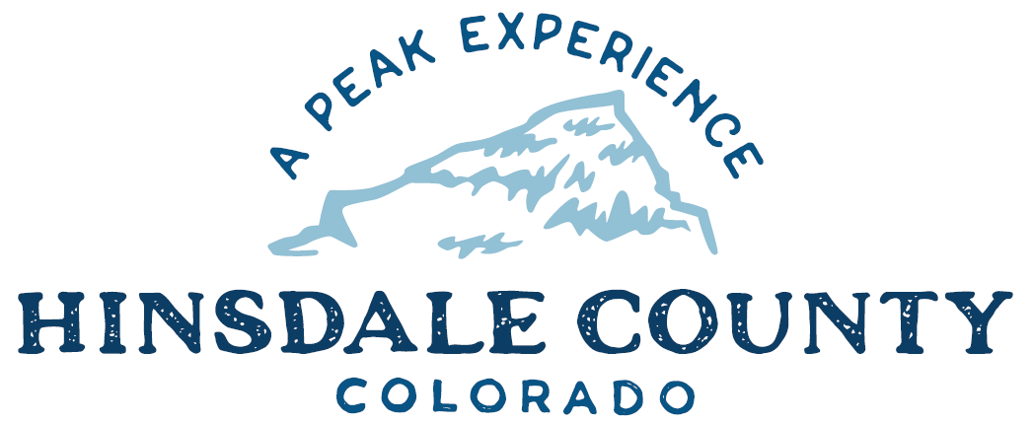

BOARD OF COUNTY COMMISSIONERS

WORKSHOP & MEETING
Coursey Annex, 311 Henson Street, Lake City

Wednesday, July 7, 2021 - 8 a.m.

Register in advance for this meeting:
https://us02web.zoom.us/meeting/register/tZcqce2rrzwsH9e8x5l9idFWA7Cx5h9zo_WT

After registering, you will receive a confirmation email containing information about joining the meeting.
If attending by phone, call 346 248 7799
Meeting ID: 837 6431 7653
Passcode: 681642

Technical difficulties may occur during the meeting due to network limitations.

8 AM OPEN DISCUSSION

8:30 AM WORKSHOP

- Discuss Assessor’s Annual Report
- Discuss Addition of Juneteenth (June 19) to County Holiday Schedule
- Discuss Gunnison County Electric Agreement Regarding Hill 71 Line Extension Fee Waivers
- Discuss Resolution Granting Buffy Witt Authority to Represent Hinsdale County on Emergency Medical Trauma Systems (EMTS) Funding Requests for Use of Western Regional Emergency Medical & Trauma Advisory County (WRETAC) Development Funds
- Discuss Resolution Terminating COVID-19 Disaster Emergency
- Discuss Lake San Cristobal Update
- Discuss Gates Foundation Grant Agreement for Lake San Cristobal Infrastructure
- Discuss DHM Contract Amendment for Lake San Cristobal Design Services
- Discuss Med 95 Ambulance Licensing
CLOSE COMMISSIONER WORKSHOP

10 AM REGULAR MEETING

Pledge of Allegiance
Modifications to the Agenda
Approval of the Agenda
Approval of the Minutes

CITIZEN COMMENTS FROM THE FLOOR

REGULAR AGENDA

- Consider Resolution Granting Buffy Witt Authority to Represent Hinsdale County on Emergency Medical Trauma Systems (EMTS) Funding Requests for Use of Western Regional Emergency Medical & Trauma Advisory County (WRETAC) Development Funds
- Consider Resolution Terminating COVID-19 Disaster Emergency
- Consider Gates Foundation Grant Agreement for Lake San Cristobal Infrastructure
- Consider DHM Contract Amendment for Lake San Cristobal Design Services
- Consider Med 95 Ambulance Licensing

ANY UNSCHEDULED BUSINESS
PRESENTATION OF BILLS TO BE PAID

REPORTS:
Commissioners
Administration
Building Official
Road and Bridge
EMS Director
Emergency Manager
Sheriff

MEETING ADJOURN

RECONVENE WORKSHOP

10. Discuss Hinsdale County Recreation Policy

ADJOURN

Times stated are approximate and the agenda may be modified as necessary at the discretion of the Board. The next Commissioner’s meeting is a workshop and regular meeting scheduled for Wednesday, July 21, 2021 unless otherwise noted at the Coursey Annex, 311 N. Henson Street, Lake City, CO 81235. Commissioner's workshop will begin at 8 AM and the regular meeting at 10:00 AM.

Two or more Hinsdale County Commissioners may attend the Town of Lake City Board of Trustees Meeting on Wednesday, July 7, 2021, at 6 p.m.

