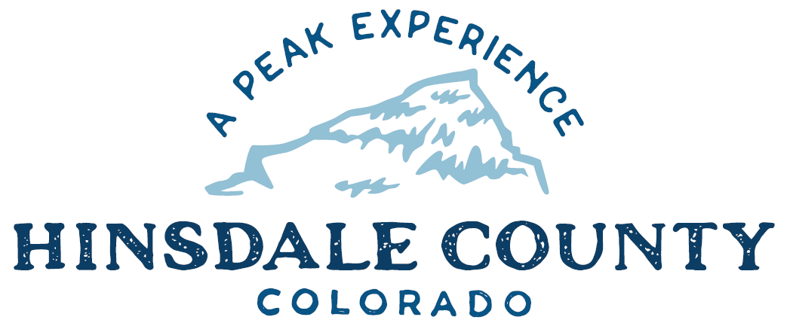

BOARD OF COUNTY COMMISSIONERS

WORKSHOP & MEETING
Coursey Annex, 311 Henson Street, Lake City

Wednesday, September 7, 2022 - 8 a.m.

8 AM OPEN DISCUSSION

8:30 AM WORKSHOP

- Discuss Early Childhood Education with Gunnison-Hinsdale Early Childhood Council
- Discuss Lake City DIRT Request for Safe Ride Vehicle
- Discuss Snowmobile Trail Grooming with Janelle Kukuk, Chair of Colorado State Trails Committee
- Discuss Lake San Cristobal Trails Plan
- Discuss Letter Regarding Colorado Water Quality Control Division’s Proposed Permit Requirements for Stormwater Discharges from Active and Inactive Metal Mining Operations
- Discuss Letter of Support for San Juan Mountains Association Grant Application
- Discuss SCS Investment Properties LLC Abatement Petition and Schedule Hearing Date
- Discuss County Participation in Family and Medical Leave Insurance Program
- Discuss Letter Supporting Good Samaritan Remediation of Abandoned Hardrock Mines Act of 2022
- Discuss Comments Regarding Countywide Flood Risk Study

CLOSE COMMISSIONER WORKSHOP

10 AM OPEN COMMISSIONERS REGULAR MEETING

Pledge of Allegiance
Modifications to the Agenda
Approval of the Agenda
Approval of the Minutes from July and August, 2022

CITIZEN COMMENTS FROM THE FLOOR

REGULAR AGENDA

- Consider Lake City DIRT Request for Safe Ride Vehicle
- Consider Letter Regarding Colorado Water Quality Control Division’s Proposed Permit Requirements for Stormwater Discharges from Active and Inactive Metal Mining Operations
- Consider Letter of Support for San Juan Mountains Association Grant Application
- Consider SCS Investment Properties LLC Abatement Petition and Schedule Hearing Date
- Consider County Participation in Family and Medical Leave Insurance Program
- Consider Letter Supporting Good Samaritan Remediation of Abandoned Hardrock Mines Act of 2022
- Consider Comments Regarding Countywide Flood Risk Study

PRESENTATION OF BILLS TO BE PAID

REPORTS:
Commissioners
Administration
Building Official
Road and Bridge
EMS Director
Emergency Manager
Sheriff

ADJOURN MEETING

1 PM RE-CONVENE WORKSHOP
- 2023 Budget Workshop #1
- Discussion with Jacob Lichty and John Whitney with Senator Michael Bennet’s Office

To attend this meeting via Zoom, register at the link below:
https://us02web.zoom.us/meeting/register/tZAqdOqtqzotGdOEHj44JiISU1vN37JI9e7J

After registering, you will receive a confirmation email containing information about joining the meeting.

Times stated are approximate and the agenda may be modified as necessary at the discretion of the Board. The next Commissioner’s meeting is a workshop and meeting scheduled for Wednesday, September 21, 2022, at the Commissioners’ Meeting Room, 311 Henson St., Lake City. The meeting will begin at 8 a.m.

Two or more commissioners may meet representatives of the Bureau of Land Management for a meet-and-greet at approximately 3 pm at Veteran's Park.

Two or more Hinsdale County Commissioners may attend the Town of Lake City Board of Trustees Meeting on Wednesday, September 7, 2022, at 6 p.m.

