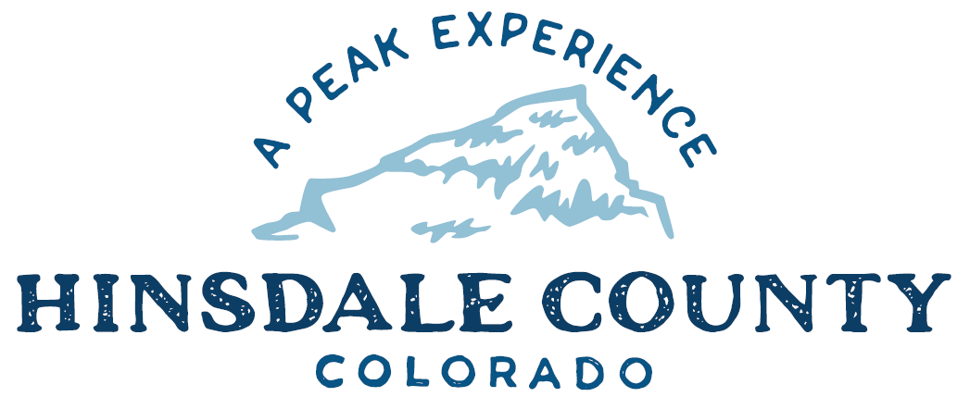

BOARD OF COUNTY COMMISSIONERS
WORKSHOP & MEETING
Coursey Annex, 311 N. Henson St., Lake City

Wednesday, September 21, 2022 – 8 a.m.
AGENDA

8 AM OPEN DISCUSSION

8:30 AM WORKSHOP

- Discuss National Incident Management System Resolution and Training
- Discuss Letter of Endorsement for Transportation Commissioners
- Discuss Resolution for Constitution Week 2022 Proclamation
- Discuss Hinsdale County Coroner Interview Committee Recommendation
- Discuss X Field Services Estimate for Transportation and Placement of Toilets
- Discuss Letter of Support for San Juan Mountains Association Grant Application
- Discuss Response to Comments Regarding Stormwater Discharges Associated with Active and Inactive Metal Mining Operations
- Discuss Letter of Support for Bureau of Land Management (BLM) Non-motorized Trail Grant
- Discuss Letter of Support for Town of Lake City’s Grant Application for Waste Water Treatment Plant Upgrades

RECESS COMMISSIONER WORKSHOP

10 AM PUBLIC HEARING – Regarding Gray Special Use Permit Application for Class B
Recreational Facility

RE-CONVENE WORKSHOP
- Discuss Gray Special Use Permit Application for Class B Recreational Facility
CLOSE COMMISSIONER WORKSHOP

OPEN COMMISSIONER’S REGULAR MEETING

Pledge of Allegiance
Modifications to the Agenda
Approval of the Agenda

2023 PROPANE SERVICE BID AWARD

CITIZEN COMMENTS FROM THE FLOOR

REGULAR AGENDA

- Consider Propane Service Bid Award for 2022 - 2023
- Consider Letter of Endorsement for Transportation Commissioners
- Consider Resolution for Constitution Week 2022 Proclamation
- Consider X Field Services Estimate for Transportation and Placement of Toilets
- Consider Letter of Support for San Juan Mountains Association Grant Application
- Consider Response to Comments Regarding Stormwater Discharges Associated with Active and Inactive Metal Mining Operations
- Consider Letter of Support for Bureau of Land Management (BLM) Non-motorized Trail Grant
- Consider Letter of Support for Town of Lake City’s Grant Application for Waste Water Treatment Plant Upgrades

TREASURER’S REPORT

PRESENTATION OF BILLS TO BE PAID

ADJOURN MEETING

To attend this meeting by Zoom, pre-register at the link below:
https://us02web.zoom.us/meeting/register/tZ0kceyvqTwqEtbZACfLIDuY-OVO_9SL-jRG

After registering, you will receive a confirmation email containing information about joining the meeting.

Times stated are approximate and the agenda may be modified as necessary at the discretion of the Board. The next Commissioner’s meeting is a workshop and meeting scheduled for Wednesday, October 5, 2022, unless otherwise noted at the Coursey Annex, 311 N. Henson Street, Lake City, CO 81235.

Two or more Hinsdale County Commissioners may attend the Town of Lake City Board of Trustees Meeting on Wednesday, September 21, 2022, at 5:30 p.m.

