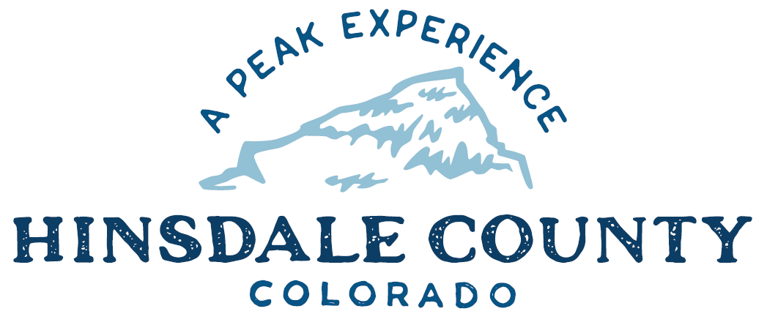

BOARD OF COUNTY COMMISSIONERS
WORKSHOP & MEETING
Coursey Annex, 311 N. Henson St., Lake City

Wednesday, August 30, 2023 – 8 a.m.
AGENDA

8 AM OPEN DISCUSSION

8:30 AM WORKSHOP

- Discuss Human Services Update with Joni Reynolds, Executive Director, Gunnison/Hinsdale Health and Human Services
- Discuss Intergovernmental Agreement (IGA) with Town of Lake City for Law Enforcement Services
- Discuss Services Agreement with Mission2Market for Tourism Marketing Strategic Plan Development
- Discuss Colorado Resource for Emergency and Trauma Education (CREATE) Grant Application for Five Hinsdale County EMTs to Attend Colorado State EMS Conference
- Discuss Liquor License Renewal for Alpine Moose Lodge
- Discuss Straw Poll Ballot Question and Wording Regarding Off-Highway Vehicles on County Roads
- Discuss Hinsdale County 150th Anniversary
- Discuss Assistance Opportunity from Colorado State University Extension Office

CLOSE COMMISSIONER WORKSHOP

OPEN COMMISSIONER’S REGULAR MEETING

Pledge of Allegiance
Modifications to the Agenda
Approval of the Agenda
Citizen Comments from the Floor

10 AM PUBLIC HEARING – To receive comments on a Special Event Liquor Permit for Lake Fork Valley Conservancy Forest Feast

REGULAR AGENDA

- Consider Approval of Special Event Liquor Permit for Lake Fork Valley Conservancy Forest Feast
- Consider Approval of IGA with Town of Lake City for Law Enforcement Services
- Consider Approval of Services Agreement with Mission2Market for Tourism Marketing Strategic Plan Development
- Consider Approval of CREATE Grant Application for Hinsdale County EMTs to Attend Colorado State EMS Conference
- Consider Approval of Liquor License Renewal for Alpine Moose Lodge

TREASURER’S REPORT
PRESENTATION OF BILLS TO BE PAID

ADJOURN MEETING

Space is limited at the Coursey Annex to attend meetings in person.
You are encouraged to attend by Zoom.

Register in advance to attend this meeting by Zoom:
https://us02web.zoom.us/meeting/register/tZYoceGurzIjE9afyHIAKnyCcPQAGhoKwHf5

After registering, you will receive a confirmation email containing information about joining the meeting.

Times stated are approximate and the agenda may be modified as necessary at the discretion of the Board. The next Commissioner’s meeting is a workshop and meeting scheduled for Wednesday, September 6, 2023, unless otherwise noted at the Coursey Annex, 311 N. Henson Street, Lake City, CO 81235.

