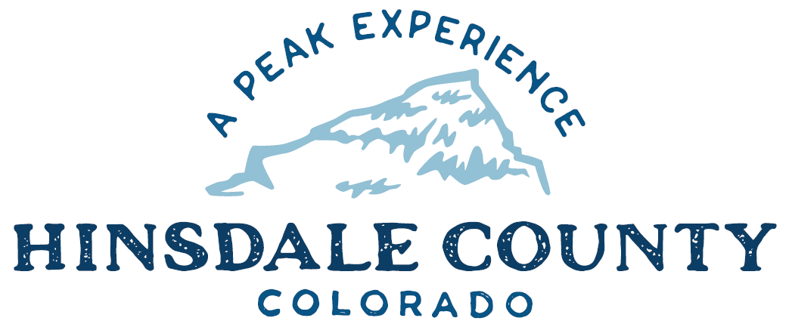

BOARD OF COUNTY COMMISSIONERS
SPECIAL WORKSHOP & MEETING
Coursey Annex, 311 N. Henson St., Lake City

Wednesday, August 17, 2022
AGENDA

Two or more commissioners will attend the Joint Mineral County/Hinsdale County discussion at Freeman’s Ranch starting at 10 a.m., to discuss items of interest to residents of the Upper Rio Grande and surrounding areas.

3 PM WORKSHOP

- Discuss 2023 Great Outdoors Colorado (GOCO) Conservation Service Corps Grant Request.
- Discuss Joint Resolution Between Hinsdale County and Hinsdale County School District Board of Education Allocating Secure Rural Schools Title 1 Monies for Fiscal years 2022, 2023 and 2024
- Discuss Memorandum of Understanding (MOU) Between U.S. Department of Interior, Bureau of Land Management (BLM), Colorado State Office and Hinsdale County for Cooperative Development of the Big Game Habitat, Movement route and Migration Corridor Resource Management Plan Amendment
- Discuss Special Events Liquor Permit for Lake Fork Valley Conservancy Fundraising Event

CLOSE COMMISSIONER WORKSHOP

3:30 PM OPEN COMMISSIONER’S REGULAR MEETING

Pledge of Allegiance
Modifications to the Agenda
Approval of the Agenda

3:35 PM PUBLIC HEARING – To receive comments on a Special Events Liquor Permit for Lake Fork Valley Conservancy Fundraising Event

CITIZEN COMMENTS FROM THE FLOOR

REGULAR AGENDA

- Consider 2023 GOCO Conservation Service Corps Grant Request
- Consider Joint Resolution Between Hinsdale County and Hinsdale County School District Board of Education Allocating Secure Rural Schools Title 1 Monies for Fiscal years 2022, 2023 and 2024
- Consider MOU Between U.S. Department of Interior, BLM, Colorado State Office and Hinsdale County for Cooperative Development of the Big Game Habitat, Movement Route and Migration Corridor Resource Management Plan Amendment
- Consider Special Events Liquor Permit for Lake Fork Valley Conservancy Fundraising Event

TREASURER’S REPORT

PRESENTATION OF BILLS TO BE PAID

ADJOURN MEETING

To join this meeting by Zoom, you must register in advance at the link:
https://us02web.zoom.us/meeting/register/tZYkce-qrDIuGdNXTLsSoYVZw8pGlCz8hSv-

After registering, you will receive a confirmation email containing information about joining the meeting.
Technical difficulties may occur during the meeting due to network limitations.

Times stated are approximate and the agenda may be modified as necessary at the discretion of the Board. The next Commissioner’s meeting is a workshop and meeting scheduled for Wednesday, August 31, 2022, unless otherwise noted at the Coursey Annex, 311 N. Henson Street, Lake City, CO 81235.

Two or more Hinsdale County Commissioners may attend the Town of Lake City Board of Trustees Meeting on Wednesday, August 17, 2022, at 6 p.m.

