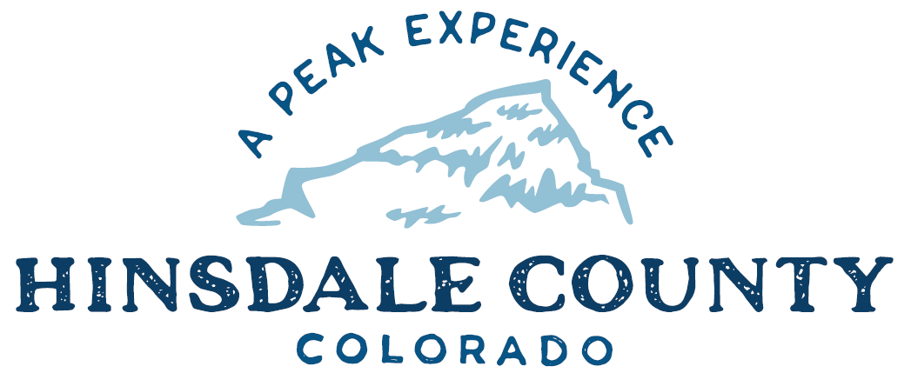

BOARD OF COUNTY COMMISSIONERS

WORKSHOP & MEETING
Coursey Annex, 311 Henson Street, Lake City

Wednesday, July 5, 2023 - 8 a.m.

8 AM OPEN DISCUSSION

8:30 AM WORKSHOP

- Discuss Oceanwave Drive Signage
- Discuss Update on Broadband Project
- Discuss Special Events Permit for Alpine 50 Bike Race on August 26, 2023
- Discuss Backcountry Search and Rescue (BSAR) Year-End Award Application
- Discuss Ben Brownlee Memorial Fund Request for Search and Rescue Snowmobile
- Discuss Greater Outdoors Colorado (GOCO) 2024 Conservation Service Corps Grant Application
- Discuss Letter of Support for Gunnison Outdoor Resources Protection (GORP) Act
- Discuss GOCO’s Notice of Restrictive Covenants (Limitations on Sale) for Lake San Cristobal Peninsula
- Discuss Special Event Liquor Permit for Lake City/Hinsdale County Chamber of Commerce for North Face Lodge Open House
- Discuss Election to Receive Secure Rural Schools Funds and Selection of Payment Methodologies

CLOSE COMMISSIONER WORKSHOP

OPEN COMMISSIONERS REGULAR MEETING

Pledge of Allegiance
Modifications to the Agenda
Approval of the Agenda
Approval of the Minutes
Citizen Comments from the Floor

REGULAR AGENDA

- Consider Special Events Permit for Alpine 50 Bike Race on August 26, 2023
- Consider BSAR Year-End Award Application
- Consider Ratification of Ben Brownlee Memorial Fund Request for Search and Rescue Snowmobile
- Consider GOCO 2024 Conservation Service Corps Grant Application
- Consider Letter of Support for GORP Act
- Consider Special Event Liquor Permit for Lake City/Hinsdale County Chamber of Commerce for North Face Lodge Open House
- Consider Election to Receive Secure Rural Schools Funds and Selection of Payment Methodologies

PRESENTATION OF BILLS TO BE PAID

REPORTS:
Commissioners
Administration
Building Official
Road and Bridge
EMS Director
Emergency Manager
Sheriff
Coroner

ADJOURN MEETING

Register in advance for this meeting:
https://us02web.zoom.us/meeting/register/tZMldOyorzorGtMBdn_2-MbI5Pv2g1zfTWw5

After registering, you will receive a confirmation email containing information about joining the meeting.

Times stated are approximate and the agenda may be modified as necessary at the discretion of the Board. The next Commissioner’s meeting is a workshop and meeting scheduled for Wednesday, July 19, 2023, unless otherwise noted at the Coursey Annex, 311 N. Henson Street, Lake City, CO 81235.

Two or more Hinsdale County Commissioners may attend the Town of Lake City Board of Trustees Meeting on Wednesday, July 5, 2023, at 5:30 p.m.

