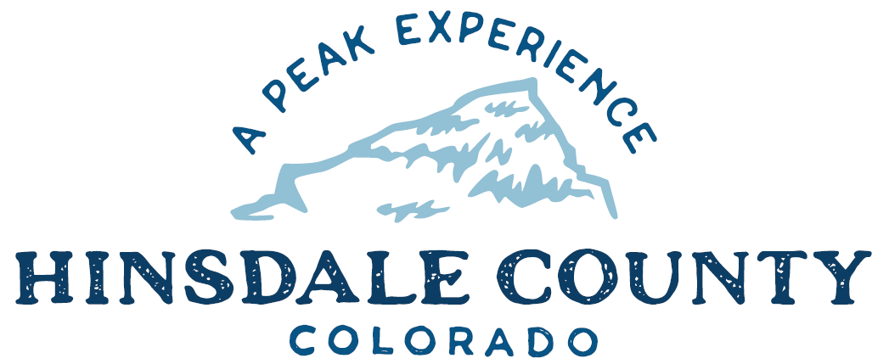

BOARD OF COUNTY COMMISSIONERS
WORKSHOP & MEETING
Coursey Annex, 311 N. Henson St., Lake City

Wednesday, July 20, 2022 – 8 a.m.
AGENDA

8 AM OPEN DISCUSSION

8:30 AM WORKSHOP

- Discuss Assessor’s Annual Report
- Discuss Evacuation Plan
- Discuss Memorandum of Understanding (MOU) with Bureau of Land Management (BLM) Establishing Hinsdale County as a Cooperating Agency for the Proposed Big Game Habitat, Movement Route and Migration Corridor Resource Management Plan Amendment
- Discuss Easement for Use of Third Street in Capitol City
- Discuss Updated Agenda Policy
- Discuss Special Events Permit for Alpine 50 Bike Race
- Discuss Colorado State Outdoor Recreation Grant for Lake San Cristobal Boat Docks
- Discuss Support of Sign-on Letter for Veterans’ Services with VA Clinics
- Discuss Updated Letter for Match Waiver for Multi-Modal Opportunity Fund (MMOF) Grant for County Road 30 Chip-seal Project
- Discuss Quarterly Budget Review
- Discuss Quarterly Grants Path

CLOSE COMMISSIONER WORKSHOP

10 AM OPEN COMMISSIONER’S REGULAR MEETING

Pledge of Allegiance
Modifications to the Agenda
Approval of the Agenda

CITIZEN COMMENTS FROM THE FLOOR

REGULAR AGENDA
- Consider Evacuation Plan
- Consider Updated Agenda Policy
- Consider Special Events Permit for Alpine 50 Bike Race
- Consider Colorado State Outdoor Recreation Grant for Lake San Cristobal Boat Docks
- Consider Support of Sign-on Letter for Veterans’ Services with VA Clinics
- Consider Updated Letter for Match Waiver for MMOF Grant for County Road 30 Chip-seal Project

PRESENTATION OF BILLS TO BE PAID

1:00 PM BOARD OF EQUALIZATION (BOE) PROTEST HEARING

EXECUTIVE SESSION: An executive session for a conference with the County Attorney for the purpose of receiving legal advice on specific legal questions pursuant to C.R.S. § 24-6-402(4)(b) in regards to the Board of Equalization.

ADJOURN MEETING

To attend this meeting by Zoom, register in advance:
https://us02web.zoom.us/meeting/register/tZYlc-GuqDIvEtdEDcbal99gkrC4VnjK_OrA

After registering, you will receive a confirmation email containing information about joining the meeting.
Technical difficulties may occur during the meeting due to network limitations.

Times stated are approximate and the agenda may be modified as necessary at the discretion of the Board. The next Commissioner’s meeting is a workshop and meeting scheduled for Wednesday, August 3, 2022, unless otherwise noted at the Coursey Annex, 311 N. Henson Street, Lake City, CO 81235.

Two or more Hinsdale County Commissioners may attend the Town of Lake City Board of Trustees Meeting on Wednesday, July 20, 2022, at 6 p.m.

