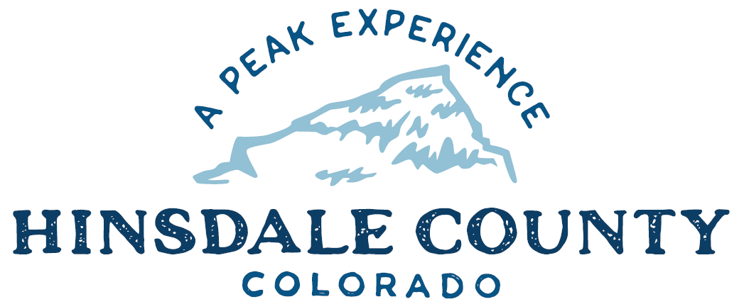

BOARD OF COUNTY COMMISSIONERS
WORKSHOP & MEETING
Coursey Annex, 311 N. Henson St., Lake City

Wednesday, July 19, 2023 – 8 a.m.
AGENDA

8 AM OPEN DISCUSSION

8:30 AM WORKSHOP

- Discuss Lake San Cristobal Peninsula Update
- Discuss GOCO’s Notice of Restrictive Covenants (Limitations on Sale) for Lake San Cristobal Peninsula
- Discuss Fire Conditions Outlook Update
- Discuss Agreement Concerning Election Services with Hinsdale County School District RE-1 and Archuleta County School District Joint 50
- Discuss Assessor’s Report of Valuation for Assessment of All Taxable Real and Personal Property in Hinsdale County.
- Discuss Agreement for Design & Engineering Services with Reynolds Ash & Associates for Schematic Plans, Design Development and Preliminary Construction Documents for County Operations Building
- Discuss Agreement for Design & Engineering Services with Reynolds Ash & Associates for Construction Documents of County Operations Building
- Discuss Energy and Mineral Impact Assistance Fund (EIAF) Grant Application for County Operations Building
- Discuss Changes to BOCC Meeting Date and Board of Equalization Meeting Dates
- Discuss Speed Limits on County Road 30
- Discuss Road and Bridge Department Expenditure of Up To $100,000 for Haul Truck

CLOSE COMMISSIONER WORKSHOP

OPEN COMMISSIONER’S REGULAR MEETING

Pledge of Allegiance
Modifications to the Agenda
Approval of the Agenda
Citizen Comments from the Floor

10 AM PUBLIC HEARING – To receive comments on a Special Event Liquor Permit for Hinsdale County Historical Society

REGULAR AGENDA

- Consider Special Events Liquor Permit for Hinsdale County Historical Society
- Consider GOCO’s Notice of Restrictive Covenants (Limitations on Sale) for Lake San Cristobal Peninsula
- Consider Agreement Concerning Election Services with Hinsdale County School District RE-1 and Archuleta County School District Joint 50
- Consider Agreement for Design & Engineering Services with Reynolds Ash & Associates for Schematic Plans, Design Development and Preliminary Construction Documents for County Operations Building
- Consider Agreement for Design & Engineering Services with Reynolds Ash & Associates for Construction Documents of County Operations Building
- Consider EIAF Grant Application for County Operations Building
- Consider Changes to BOCC Meeting Date and Board of Equalization Meeting Dates
- Consider Road and Bridge Department Expenditure of Up To $100,000 for Haul Truck

TREASURER’S REPORT
PRESENTATION OF BILLS TO BE PAID

ADJOURN MEETING

Register in advance for this meeting:
https://us02web.zoom.us/meeting/register/tZMpfuGrqz0tHtbBAteQXSN2mg-cjOZR7jPG

After registering, you will receive a confirmation email containing information about joining the meeting.

Times stated are approximate and the agenda may be modified as necessary at the discretion of the Board. The next Commissioner’s meeting is a workshop and meeting scheduled for Wednesday, August 2, 2023, unless otherwise noted at the Coursey Annex, 311 N. Henson Street, Lake City, CO 81235.

Two or more Hinsdale County Commissioners may attend the Town of Lake City Board of Trustees Meeting on Wednesday, July 19, 2023, at 5:30 p.m.

