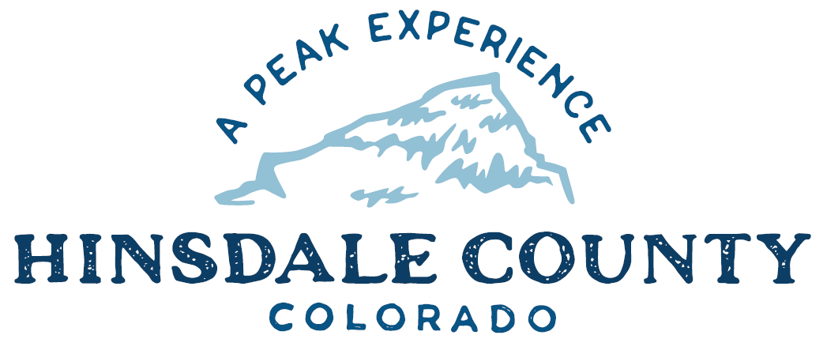

BOARD OF COUNTY COMMISSIONERS
WORKSHOP & MEETING
Coursey Annex, 311 N. Henson St., Lake City

Wednesday, June 29, 2022 – 8 a.m.
AGENDA

Register in advance for this meeting:
https://us02web.zoom.us/meeting/register/tZIvceqhrT0pGtOHYnvQvoXYxU-qcgGorOmu

After registering, you will receive a confirmation email containing information about joining the meeting.

8 AM OPEN DISCUSSION

8:30 AM WORKSHOP

- Discuss Deer Lakes Recreation Area with Colorado Parks and Wildlife Representatives Brandon Diamond and Lucas Martin, and USDA Forest Service Gunnison District Ranger Dayle Funka
- Discuss Agreement to Amend-Extend Contract Between Hinsdale County and Josh Gray for Sale of Mt. Morris Lode
- Discuss 2022 Intergovernmental Agreement (IGA) with Gunnison Watershed Weed Commission for Undesirable Plant Management
- Discuss Approval of Special Event Permit for Hardrock 100 Endurance Run
- Discuss Lake City/Hinsdale County Chamber of Commerce Request for Authorization of Public Fireworks Display in Memorial Park on July 3, 2022
- Discuss Funding Agreement with Upper Gunnison River Water Conservancy District (UGRWCD) for Hinsdale County Campground Water System Design
- Discuss Authorization of Electronic Recording Technology Board (ERTB) Fund Grant for Hinsdale County Clerk Electronic Filing System
- Discuss Letter Regarding 2013 Narrowband Mandate for Radio Communications
- Discuss Resolution to Increase Project Cost for Multi-Modal Opportunity Fund (MMOF) Grant Application
- Discuss Hiring of a Relative of Existing Employee in Road and Bridge Department

CLOSE COMMISSIONER WORKSHOP

10:30 AM OPEN COMMISSIONER’S REGULAR MEETING

Pledge of Allegiance
Modifications to the Agenda
Approval of the Agenda

CITIZEN COMMENTS FROM THE FLOOR

REGULAR AGENDA

- Consider Agreement to Amend-Extend Contract Between Hinsdale County and Josh Gray for Sale of Mt. Morris Lode
- Consider 2022 IGA with Gunnison Watershed Weed Commission for Undesirable Plant Management
- Consider Approval of Special Event Permit for Hardrock 100 Endurance Run
- Consider Lake City/Hinsdale County Chamber of Commerce Request for Authorization of Public Fireworks Display in Memorial Park on July 3, 2022
- Consider Funding Agreement with UGRWCD for Hinsdale County Campground Water System Design
- Consider Authorization of ERTB Fund Grant for Hinsdale County Clerk Electronic Filing System
- Consider Letter Regarding 2013 Narrowband Mandate for Radio Communications
- Consider Resolution to Increase Project Cost for MMOF Grant Application
- Consider Hiring of a Relative of Existing Employee in Road and Bridge Department

PRESENTATION OF BILLS TO BE PAID

ADJOURN MEETING

RECONVENE WORKSHOP

11 AM Discuss Broadband Project Update with Michelle Haynes and Corey Bryndal, Region 10 and Justin Davis, Visionary Broadband

1 PM Field trip with Jon Kaminsky, Bureau of Land Management Field Manager to Peninsula, Capitol City, and other sites

ADJOURN WORKSHOP

Times stated are approximate and the agenda may be modified as necessary at the discretion of the Board. The next Commissioner’s meeting is a workshop and meeting scheduled for Wednesday, July 6, 2022, unless otherwise noted at the Coursey Annex, 311 N. Henson Street, Lake City, CO 81235.

Two or more Hinsdale County Commissioners may attend the Town of Lake City Board of Trustees Meeting on Wednesday, July 6, 2022, at 6 p.m.

