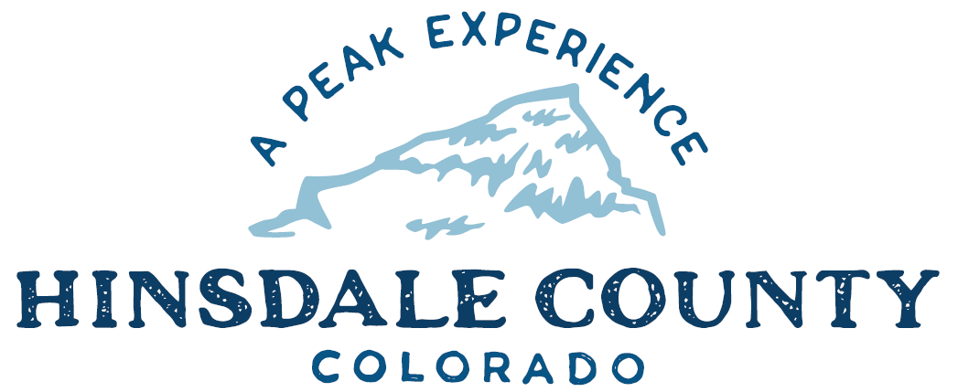

BOARD OF COUNTY COMMISSIONERS

WORKSHOP & MEETING
Coursey Annex, 311 Henson Street, Lake City

Wednesday, June 1, 2022 - 8 a.m.

Register in advance for this meeting:
https://us02web.zoom.us/meeting/register/tZYvf-CqpjopGNU1yINDbC8Zs5x-CSEkOieb

After registering, you will receive a confirmation email containing information about joining the meeting.
8 AM OPEN DISCUSSION

8:30 AM WORKSHOP

- Discuss Silver Thread Public Health District (STPHD) American Rescue Plan Act (ARPA) Premium Pay Funds – STPHD Director Tara Hardy
- Discussion with Naomi Dobbs, Southwest Regional Representative for Congresswoman Lauren Boebert
- Discuss Gabe McNeese Employment Agreement, Building and Enforcement Officer
- Discuss Ratification of 2022 Law Enforcement Operating and Financial Plan with Grand Mesa, Uncompahgre and Gunnison (GMUG) National Forest, and Rio Grande National Forest
- Discuss Special Event Permit for Lake Fork Valley Conservancy’s (LFVC) Lake Fork of the Gunnison River Festival
- Discuss Special Event Permit for San Juan Solstice 50 Mile Endurance Run
- Discuss Fire Conditions Outlook Update
- Discuss Alert & Warning Plan
- Discuss Plan for South Conservation Corps Red Mountain Gulch Cleanup
- Discuss Scenic Byways Grant Application
- Discuss Liquor License Renewal for Sportsmans BBQ Station & Backyard
- Discuss Resolution Allocating Title I and Title III Funds
- Discuss Title 1 Secure and Rural Schools Letter of Agreement with Hinsdale County School Board for 2022, 2023, and 2024
- Discuss First Amendment to Antenna Tower Space Lease Agreement with Visionary Communications
- Discuss Treasurer Report and Available County Funds

CLOSE COMMISSIONER WORKSHOP

10 AM REGULAR MEETING

- Consider STPHD ARPA Premium Pay Funds
- Consider Gabe McNeese Employment Agreement, Building and Enforcement Officer
- Consider Ratification of 2022 Law Enforcement Operating and Financial Plan with Grand Mesa, Uncompahgre and Gunnison (GMUG) National Forest, and Rio Grande National Forest
- Consider Special Event Permit for LFVC’s Lake Fork of the Gunnison River Festival
- Consider Special Event Permit for San Juan Solstice 50 Mile Endurance Run
- Consider Alert & Warning Plan
- Consider Scenic Byways Grant Application
- Consider Sportsmans BBQ Station & Backyard Liquor License Renewal
- Consider Resolution Allocating Title I and Title III Funds
- Consider Title 1 Secure and Rural Schools Letter of Agreement with Hinsdale County School Board for 2022, 2023 and 2024
- Consider First Amendment to Antenna Tower Space Lease Agreement with Visionary Communications

` Pledge of Allegiance
Modifications to the Agenda
Approval of the Agenda
Approval of the Minutes

CITIZEN COMMENTS FROM THE FLOOR

PRESENTATION OF BILLS TO BE PAID

REPORTS:
Commissioners
Administration
Building Official
Road and Bridge
EMS Director
Emergency Manager
Sheriff

ADJOURN MEETING

Times stated are approximate and the agenda may be modified as necessary at the discretion of the Board. Times stated are approximate and the agenda may be modified as necessary at the discretion of the Board. The next Commissioner’s meeting is a workshop and regular meeting on June 15, 2022, at the Sportsman’s Campground, 2095 Taylor Lane, Pagosa Springs. Meeting will begin at 11 AM.

Two or more Hinsdale County Commissioners may attend the Town of Lake City Board of Trustees Meeting on Wednesday, June 1, at 6 p.m.

