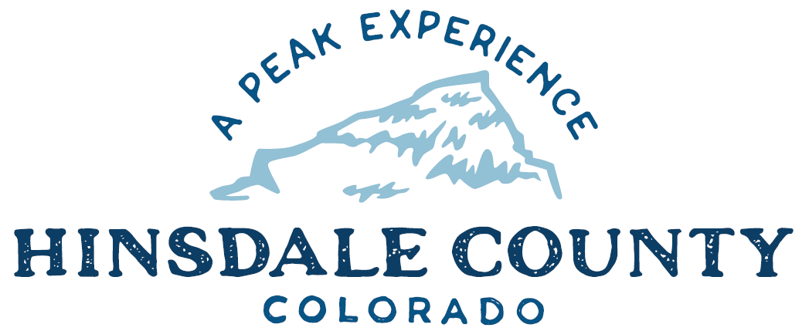

BOARD OF COUNTY COMMISSIONERS
WORKSHOP & MEETING
Coursey Annex, 311 N. Henson St., Lake City

Wednesday, May 31, 2023 – 8 a.m.
AGENDA

8 AM OPEN DISCUSSION

8:30 AM WORKSHOP

- Discuss Resolution Adopting an Amended Grants Policy
- Discuss Road Agreement with San Juan National Forest (SJNF)
- Discuss Colorado State Forest Service 2023 Incentives for Local Government Project Award Notification and Initial Scope of Work
- Discuss Agreement for Soil Engineering Services with CMT Technical Services
- Discuss Special Event Permit for Lake Fork Valley Conservancy’s (LFVC) Lake Fork of the Gunnison River Festival
- Discuss Ratification of Cooperative Law Enforcement Agreement with Rio Grande National Forest (RGNF) and Grand Mesa, Uncompahgre and Gunnison (GMUG) National Forest
- Discuss Quarterly Grants Path
- Discuss 2023 Goals Update

CLOSE COMMISSIONER WORKSHOP
OPEN COMMISSIONER’S REGULAR MEETING

Pledge of Allegiance
Modifications to the Agenda
Approval of the Agenda
Citizen Comments from the Floor

REGULAR AGENDA

- Consider Resolution Adopting an Amended Grants Policy
- Consider Road Agreement with SJNF
- Consider Colorado State Forest Service 2023 Incentives for Local Government Project Award Notification and Initial Scope of Work
- Consider Agreement for Soil Engineering Services with CMT Technical Services
- Consider Special Event Permit for LFVC’s Lake Fork of the Gunnison River Festival
- Consider Ratification of Cooperative Law Enforcement Agreement with RGNF and GMUG National Forest

PRESENTATION OF BILLS TO BE PAID

ADJOURN MEETING

1 PM RE-CONVENE WORKSHOP
- Discuss Brownfields Assessment Project with Ayres Associates, Environmental Protection Agency and Colorado Department of Public Health and Environment.
- Discuss FirstNet with John Matovich, AT&T

Register in advance for this meeting:
https://us02web.zoom.us/meeting/register/tZAlfu-urTIvGNRG_pCoGa86GD_TBbxUPNJl

After registering, you will receive a confirmation email containing information about joining the meeting.

Times stated are approximate and the agenda may be modified as necessary at the discretion of the Board. The next Commissioner’s meeting is a workshop and meeting scheduled for Wednesday, June 7, 2023, unless otherwise noted at the Coursey Annex, 311 N. Henson Street, Lake City, CO 81235.

