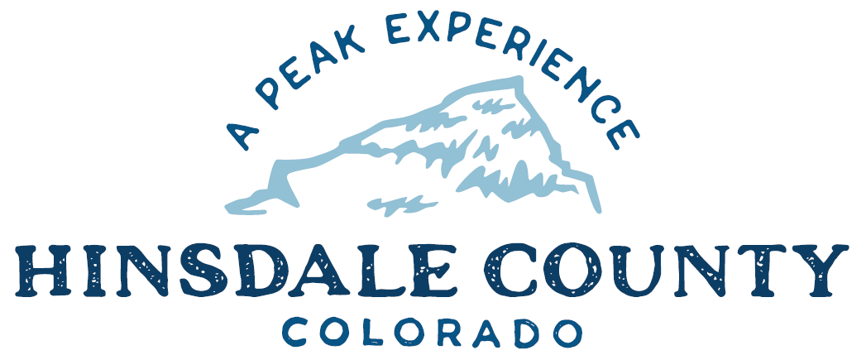

BOARD OF COUNTY COMMISSIONERS
WORKSHOP & MEETING
Coursey Annex, 311 N. Henson St., Lake City

Wednesday, May 17, 2023 – 8 a.m.
AGENDA

8 AM OPEN DISCUSSION

8:30 AM WORKSHOP

- Discuss All Hazards Team Program
- Discuss Peninsula Update
- Discuss Secure Rural Schools (SRS) Fund Resolution
- Discuss Quarterly Budget Update
- Discuss 401(a) and 457 Retirement Plans
- Discuss Colorado State Forest Service 2023 Incentives for Local Government Grant
- Discuss National Scenic Byways Program Grant
- Discuss Letter of Support for Hinsdale County Historical Society’s Microgrant Application to State Historic Fund

CLOSE COMMISSIONER WORKSHOP

OPEN COMMISSIONER’S REGULAR MEETING

Pledge of Allegiance
Modifications to the Agenda
Approval of the Agenda
Citizen Comments from the Floor

REGULAR AGENDA

- Consider Secure Rural Schools SRS) Fund Resolution
- Consider 401(a) and 457 Retirement Plans
- Consider Letter of Support for Hinsdale County Historical Society’s Microgrant Application to State Historic Fun

TREASURER’S REPORT
PRESENTATION OF BILLS TO BE PAID

ADJOURN MEETING

Register in advance for this meeting:
https://us02web.zoom.us/meeting/register/tZMuc-urqz0oGNIfEGVQqyN7zpB0yQNK4oPg

After registering, you will receive a confirmation email containing information about joining the meeting.

Times stated are approximate and the agenda may be modified as necessary at the discretion of the Board. The next Commissioner’s meeting is a workshop and meeting scheduled for Wednesday, May 31, 2023, unless otherwise noted at the Coursey Annex, 311 N. Henson Street, Lake City, CO 81235.

BOCC/BOT Joint Workshop 5/17/23 5:00pm
Town of Lake City
May 17, 2023 at 5:00 PM MDT to May 17, 2023 at 6:00 PM MDT
230 N. Bluff Armory Multi-Purpose Room

Agenda
- BOCC/BOT Joint Workshop - 5:00pm
  - Discuss Process for Public Comment on Town/County Program Allowing OHVs on Highway 149
  - Discuss Scenic Byways Program Grant (Kristine Borchers)
  - Discuss County Partnering with the Town on the Use of Granicus to Identify Short Term Rentals
  - GCEA Update by Mike McBride CEO
  - Discuss Lake San Cristobal Infill (Robert Hurd)

In order to attend this meeting by Zoom, pre-register at the link below:
https://us06web.zoom.us/meeting/register/tZIkdeCppjwqG9CrxbXlDbEI1-0dfTK_Tbjw
After registering, you will receive a confirmation email containing information about joining the meeting.

