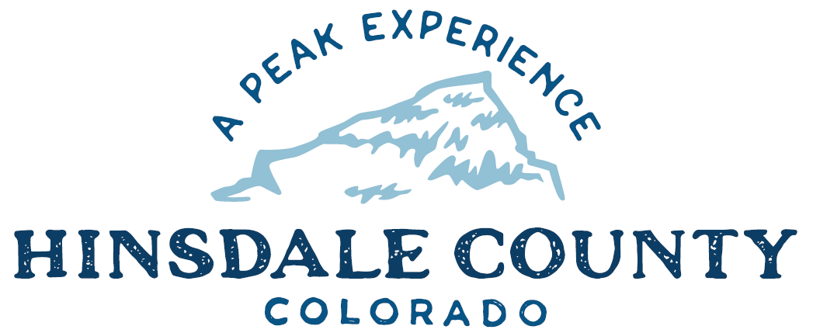

BOARD OF COUNTY COMMISSIONERS

WORKSHOP & MEETING
Coursey Annex, 311 Henson Street, Lake City

Wednesday, April 6, 2022 - 8 a.m.

Register in advance for this meeting:
https://us02web.zoom.us/meeting/register/tZcudeGvrz4pHNZJ7S97vStCuxu13m2urmhG

After registering, you will receive a confirmation email containing information about joining the meeting.
Technical difficulties may occur during the meeting due to network limitations.

8 AM OPEN DISCUSSION

8:30 AM WORKSHOP

- Discuss Van Usage by Non-County Users
- Discuss DHM Design for accessible Fishing Pier design and next steps with Fishing is Fun! grant
- Discuss Federal Emergency Management Agency (FEMA) Draft Flood Insurance Rate Map (FIRM)
- Discuss Resolution Supporting Protection of Southern Ute Indian Tribe’s 1874 Brunot Treaty Ancestral Hunting Area and Rights in Regards to Wolf Reintroduction
- Discuss Modification of Forest Service Agreement for Magnesium Chloride on San Juan National Forest Road 631 (Piedra Road) FY2022
- Discuss Lake San Cristobal Water Usage by Colorado Department of Transportation (CDOT) Contractor United Companies for Hwy 149 Resurfacing Project
- Discuss Lease-Purchase Agreement with Caterpillar for Road and Bridge Compactor
- Discuss Transfer Station Mitigation Debris Incentive Program and Update to Transfer Station Fee Schedule
- Discuss Special Use Permit Application Form and Policy
- Discuss Recreation Policy
- Discuss Resolution Amending Appointments Important to the County for 2022

CLOSE COMMISSIONER WORKSHOP

10 AM REGULAR MEETING

` Pledge of Allegiance
Modifications to the Agenda
Approval of the Agenda
Approval of the Minutes

CITIZEN COMMENTS FROM THE FLOOR

REGULAR AGENDA

- Consider Resolution Supporting Protection of Southern Ute Indian Tribe’s 1874 Brunot Treaty Ancestral Hunting Area and Rights in Regards to Wolf Reintroduction
- Consider Modification of Forest Service Agreement for Magnesium Chloride on San Juan National Forest Road 631 (Piedra Road) FY2022
- Consider Lake San Cristobal Water Usage by Colorado Department of Transportation (CDOT) Contractor United Companies for Hwy 149 Resurfacing Project
- Consider Lease-Purchase Agreement with Caterpillar for Road and Bridge Compactor
- Consider Updated Transfer Station Fee Schedule
- Consider Special Use Permit Application Form and Policy
- Consider Resolution Amending Appointments Important to the County for 2022

ANY UNSCHEDULED BUSINESS
PRESENTATION OF BILLS TO BE PAID

REPORTS:
Commissioners
Administration
Building Official
Road and Bridge
EMS Director
Emergency Manager
Sheriff

ADJOURN MEETING

Times stated are approximate and the agenda may be modified as necessary at the discretion of the Board. The next Commissioner’s meeting is Commissioners scheduled for Wednesday, April 20, 2022, at the Commissioners’ Meeting Room, 311 Henson St., Lake City. The meeting will begin at 8 a.m.

Two or more Hinsdale County Commissioners may attend the Town of Lake City Board of Trustees Meeting on Wednesday, April 6, at 6 p.m.

