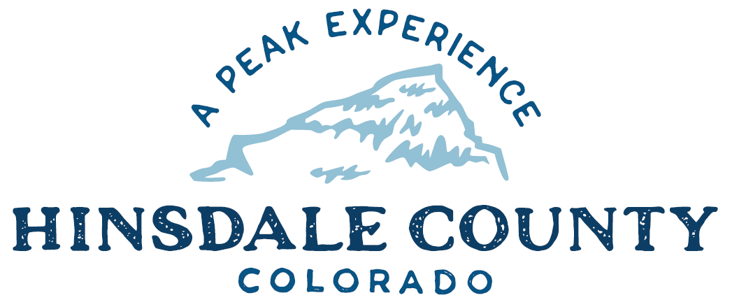

BOARD OF COUNTY COMMISSIONERS
WORKSHOP & MEETING
Coursey Annex, 311 N. Henson St., Lake City

Wednesday, April 20, 2022 – 8 a.m.
AGENDA

Register in advance for this meeting:
https://us02web.zoom.us/meeting/register/tZUoduirpj0sE9P80w1E3a7C4c5hkwax7SV4

After registering, you will receive a confirmation email containing information about joining the meeting.
Technical difficulties may occur during the meeting due to network limitations.

8 AM OPEN DISCUSSION

8:30 AM WORKSHOP

- Discuss Lake San Cristobal Update
- Discuss Argo Mill Tour Dates
- Discuss First Quarter Budget Update
- Discuss Reduced Courthouse Days of Operation – Treasurer, Deputy Assessor, Clerk
- Discuss Resolution Adopting Special Events Policy
- Discuss Disposal of County Surplus Equipment Policy
- Discuss Scenic Byways Funding
- Discuss Resolution Amending Appointments Important to the County for 2022

CLOSE COMMISSIONER WORKSHOP

10 AM OPEN COMMISSIONER’S REGULAR MEETING

Pledge of Allegiance
Modifications to the Agenda
Approval of the Agenda

CITIZEN COMMENTS FROM THE FLOOR

REGULAR AGENDA

- Consider Resolution Adopting Special Events Policy
- Consider Disposal of County Surplus Equipment Policy
- Consider Resolution Amending Appointments Important to the County for 2022

PRESENTATION OF BILLS TO BE PAID

ADJOURN MEETING

Times stated are approximate and the agenda may be modified as necessary at the discretion of the Board. The next Commissioner’s meeting is a workshop and meeting scheduled for Wednesday, May 4, 2022, unless otherwise noted at the Coursey Annex, 311 N. Henson Street, Lake City, CO 81235.

Two or more Hinsdale County Commissioners may attend the Town of Lake City Board of Trustees Meeting on Wednesday, April 20, 2022, at 6 p.m.

