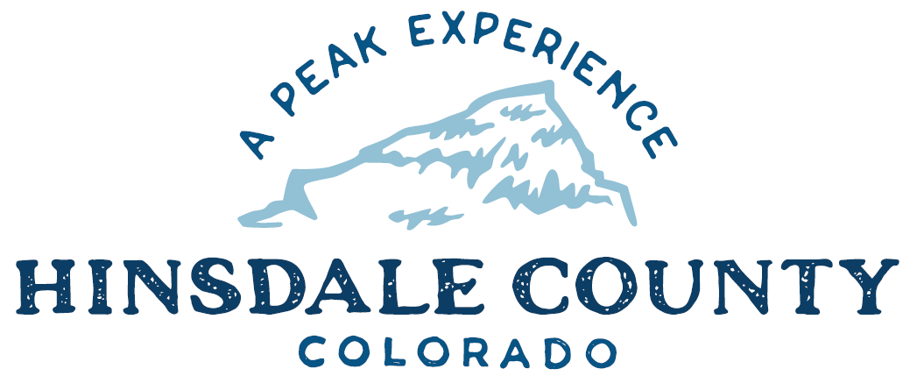

BOARD OF COUNTY COMMISSIONERS

WORKSHOP & MEETING
Coursey Annex, 311 Henson Street, Lake City

Wednesday, February 2, 2022 - 8 a.m.

Register in advance for this meeting:
https://us02web.zoom.us/meeting/register/tZUud-uorDgpGdAK3Rs1344MAIyhSb0UjP_r

After registering, you will receive a confirmation email containing information about joining the meeting.
Technical difficulties may occur during the meeting due to network limitations.

8 AM OPEN DISCUSSION

8:30 AM WORKSHOP

- Discuss Lake City Alpine 50 Request to Close Portion of CR 20 for August 27 Bike Race
- Discuss Golden Wonder Mine with LKA Gold Incorporated Owner Kye Abraham
- Discuss Sale of Hinsdale County Capitol City Properties
- Discuss Special Events Policy and Permit Application
- Discuss America’s Byways Silver Thread Scenic & Historic Byway Viewshed Improvement Award Application Letter of Support
- Discuss Resolution Setting County Mileage Reimbursement Rate
- Discuss Colorado Parks and Wildlife Impact Assistance Grant Application
- Discuss Chadwick, Steinkirchner, Davis & Co Audit Engagement Letter for 2021 Audit
- Discuss Colorado State Historical Fund Project, FS Road 520 Signage Operations and Maintenance Plan
- Discuss Interrogatory Responses in Civil Action Norman Ragle vs Hinsdale County Board of Commissioners
- Discuss Upper Gunnison River Water Conservancy District 2022 Grant Application for Wupperman Campground Water System Design

CLOSE COMMISSIONER WORKSHOP

10 AM REGULAR MEETING

` Pledge of Allegiance
Modifications to the Agenda
Approval of the Agenda
Approval of the Minutes

Presentation of Bill Conroy Award to Veterans Services Officer Erin Cavit

CITIZEN COMMENTS FROM THE FLOOR

REGULAR AGENDA

- Consider America’s Byways Silver Thread Scenic & Historic Byway Viewshed Improvement Award Application Letter of Support
- Consider Resolution Setting County Mileage Reimbursement Rate
- Consider Colorado Parks and Wildlife Impact Assistance Grant Application
- Consider Chadwick, Steinkirchner, Davis & Co Audit Engagement Letter for 2021 Audit
- Consider Colorado State Historical Fund Project, FS Road 520 Signage Operations and Maintenance Plan
- Consider Interrogatory Responses in Civil Action Norman Ragle vs Hinsdale County Board of Commissioners
- Consider Upper Gunnison River Water Conservancy District (UGRWCD) 2022 Grant Application for Wupperman Campground Water System Design

ANY UNSCHEDULED BUSINESS
PRESENTATION OF BILLS TO BE PAID

REPORTS:
Commissioners
Administration
Building Official
Road and Bridge
EMS Director
Emergency Manager
Sheriff

ADJOURN

Times stated are approximate and the agenda may be modified as necessary at the discretion of the Board. The next Commissioner’s meeting is Commissioners scheduled for Wednesday, February 16, 2022, at the Commissioners’ Meeting Room, 311 Henson St., Lake City. The meeting will begin at 8 a.m.

Two or more Hinsdale County Commissioners may attend the Town of Lake City Board of Trustees Meeting on Wednesday, February 2, at 6 p.m.

