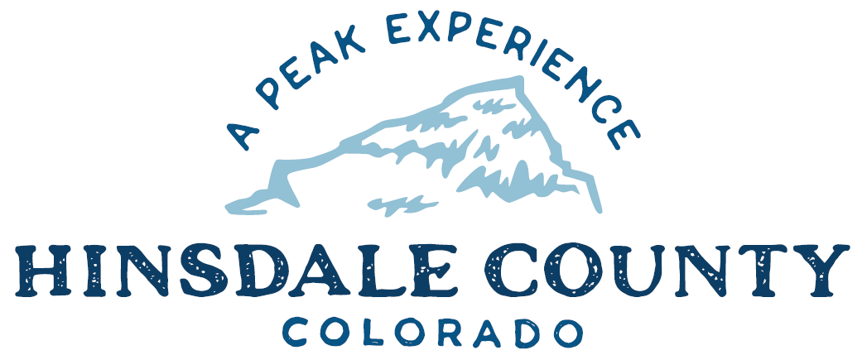

BOARD OF COUNTY COMMISSIONERS
WORKSHOP & MEETING
Coursey Annex, 311 N. Henson St., Lake City

Wednesday, February 15, 2023 – 8 a.m.
AGENDA

8 AM OPEN DISCUSSION

8:30 AM WORKSHOP

- Discuss Deer Lakes with Dayle Funka, District Ranger, Grand Mesa, Uncompahgre and Gunnison National Forest and Brandon Diamond and Other Colorado Parks and Wildlife Representatives
- Discuss Letter of Support for National Forest Foundation Laura Jane Musser Grant Application
- Discuss Colorado Parks and Wildlife Impact Assistance Grant Application
- Discuss Cooperative Forest Road Agreement with San Juan National Forest
- Discuss Amended Off-Highway Vehicle (OHV) Ordinance
- Discuss Request for Proposals and Qualifications (RFP/Q) for CR 30 Bike Lane Installation and Chip and Seal Overlay Design Services
- Discuss Letter of Intent to Participate in the Hinsdale County Multi-Jurisdictional Hazard Mitigation Plan Effort
- Discuss Funding Match Commitment Letter and Related Documents for Hazard Mitigation Assistance Planning Grant
- Discuss County Coalition Updated Intergovernmental Agreement (IGA) for Conservation of Native Fish Populations including the Cutthroat Trout, Chub and Sucker in the Rio Grande River Watershed
- Discuss Backcountry Search and Rescue (BSAR) Flexible Fund Grant Program Application
- Discuss Wolf Restoration Program Comment Letter
- Discuss Amended Hinsdale County Operating Plan with Colorado Division of Fire Prevention and Control
- Discuss Amended Professional Services Contract with EMS Physician Advisor Dr. Gina Carr
- Discuss Letter of Support to Hinsdale County Historical Society for Historic Rail Car 211 Grant Applications
- Discuss County Jeep Use with Tara Hardy, Director, Silver Thread Public Health District

CLOSE COMMISSIONER WORKSHOP
OPEN COMMISSIONER’S REGULAR MEETING

Open Proposals for Design and Construction Documents for County Operations Building

Pledge of Allegiance
Modifications to the Agenda
Approval of the Agenda

CITIZEN COMMENTS FROM THE FLOOR

REGULAR AGENDA

- Consider Letter of Support for National Forest Foundation Laura Jane Musser Grant Application
- Consider Colorado Parks and Wildlife Impact Assistance Grant Application
- Consider Cooperative Forest Road Agreement with San Juan National Forest
- Consider Amended OHV Ordinance
- Consider RFP/Q for CR 30 Bike Lane Installation and Chip and Seal Overlay Design Services
- Consider Letter of Intent to Participate in the Hinsdale County Multi-Jurisdictional Hazard Mitigation Plan Effort
- Consider Funding Match Commitment Letter and Related Documents for Hazard Mitigation Assistance Planning Grant
- Consider County Coalition Updated IGA for Conservation of Native Fish Populations including the Cutthroat Trout, Chub and Sucker in the Rio Grande River Watershed
- Consider BSAR Flexible Fund Grant Program Application
- Consider Wolf Restoration Program Comment Letter
- Consider Amended Hinsdale County Operating Plan with Colorado Division of Fire Prevention and Control
- Consider Amended Professional Services Contract with EMS Physician Advisor Gina Carr
- Consider Letter of Support to Hinsdale County Historical Society for Historic Rail Car 211 Grant Applications

TREASURER’S REPORT
PRESENTATION OF BILLS TO BE PAID

ADJOURN MEETING

- PM RE-CONVENE WORKSHOP
- Discuss Colorado Parks and Wildlife/National Parks Service Lake San Cristobal Boat Inspection Program

Register in advance for this meeting:
https://us02web.zoom.us/meeting/register/tZYvd-mtqDgsE92_RRsWTMm9WWz_nkBgVjCg
After registering, you will receive a confirmation email containing information about joining the meeting.

Times stated are approximate and the agenda may be modified as necessary at the discretion of the Board. The next Commissioner’s meeting is a workshop and meeting scheduled for Wednesday, March 1, 2023, unless otherwise noted at the Coursey Annex, 311 N. Henson Street, Lake City, CO 81235.
Two or more Hinsdale County Commissioners may attend the Town of Lake City Board of Trustees Meeting on Wednesday, February 15, 2023, at 5:30 p.m.

