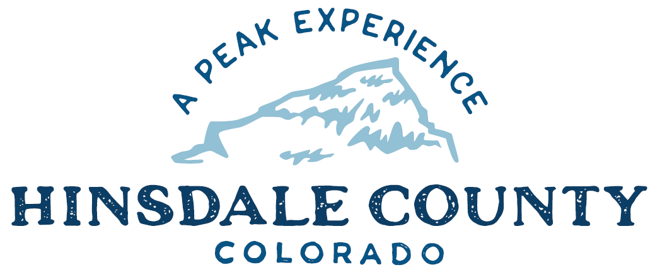

BOARD OF COUNTY COMMISSIONERS
WORKSHOP & MEETING
Coursey Annex, 311 N. Henson St., Lake City

Wednesday, December 21, 2022 – 8 a.m.
AGENDA

8 AM OPEN DISCUSSION

8:30 AM WORKSHOP

- Discuss Resolution Adopting the 2023 Hinsdale County Budget
- Discuss 2022 Certification of Mill Levies and Revenues
- Discuss Resolution Making Appointments to the County for 2023
- Discuss Adoption of Continuity of Government Plan
- Discuss Greg Collins Appointment to Hinsdale County Lodging Tax Board
- Discuss Maintenance, Repair and Storage Agreement with Lake City Continental Divide Snowmobile Club
- Discuss Disposal of Road and Bridge Trailer
- Discuss Reimbursement for Magnesium Chloride Application on Forest Service Road 520
- Discuss Letter of Engagement with Blair and Associates for 2022 Year End Audit Services
- Discuss Certification Statement for new FCC Frequencies for South End Communication Tower

CLOSE COMMISSIONER WORKSHOP

OPEN COMMISSIONER’S REGULAR MEETING

Pledge of Allegiance
Modifications to the Agenda
Approval of the Agenda

10 AM PUBLIC HEARING – 2023 Hinsdale County Budget

CITIZEN COMMENTS FROM THE FLOOR

REGULAR AGENDA

- Consider Resolution Adopting the 2023 Hinsdale County Budget
- Consider Budget Year 2023 Certification of Mill Levies and Revenues
- Consider Resolution Making Appointments to the County for 2023
- Consider Adoption of Continuity of Government Plan
- Consider Greg Collins Appointment to Hinsdale County Lodging Tax Board
- Consider Maintenance, Repair and Storage Agreement with Lake City Continental Divide Snowmobile Club
- Consider Letter of Engagement with Blair and Associates for 2022 Year End Audit Services
- Consider Certification Statement for new FCC Frequencies for South End Communication Tower
TREASURER’S REPORT

PRESENTATION OF BILLS TO BE PAID

ADJOURN MEETING

- PM RE-CONVENE WORKSHOP

- Discuss Rio Grande Reservoir Rehabilitation Project Recreational & Environmental Provisions

Register in advance to join this meeting by Zoom:
https://us02web.zoom.us/meeting/register/tZ0kceiuqzopE9GMxXKU0RqGgc66YO7_42RK

After registering, you will receive a confirmation email containing information about joining the meeting.

Times stated are approximate and the agenda may be modified as necessary at the discretion of the Board. The next Commissioner’s meeting is a workshop and meeting scheduled for Wednesday, December 28, 2022, unless otherwise noted at the Coursey Annex, 311 N. Henson Street, Lake City, CO 81235.

Two or more Hinsdale County Commissioners may attend the Town of Lake City Board of Trustees Meeting on Wednesday, December 21, 2022, at 5:30 p.m.

