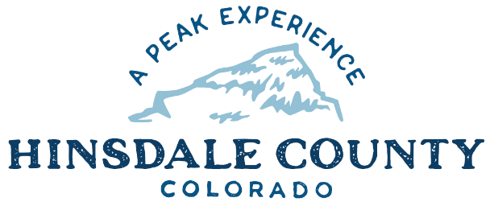
+
HINSDALE COUNTY

BOARD OF COUNTY COMMISSIONERS WORKSHOP & MEETING
Coursey Annex, 311 North Henson St.
Lake City, CO

Wednesday, December 16, 2020

REVISED AGENDA

You are invited to a Zoom meeting.
When: Dec 16, 2020 08:00 AM Mountain Time (US and Canada)

Register in advance for this meeting:
https://us02web.zoom.us/meeting/register/tZApdeuvqT0jE9K2M9xPXN-cYD3CviZ_pANe

After registering, you will receive a confirmation email containing information about joining the meeting.

If attending by phone, call 346 248 7799
Meeting ID: 844 2277 6996
Passcode: 841521
_________________________________________________________________________________

8:15 AM OPEN DISCUSSION

8:30 AM WORKSHOP

- Discuss Lake San Cristobal Peninsula Agreement for Conveyance of Real Property – Commissioner Kristie Borchers
- Discuss Lake San Cristobal Master Plan – Commissioner Kristie Borchers
- Discuss Resolution Adopting the 2021 Hinsdale County Budget – Finance Director Lynn McNitt
- Discuss Resolution Fixing County Mill Levies for 2020 – Administrator Sandy Hines
- Discuss 2020 Certification of Levies and Revenues – Administrator Sandy Hines
- Discuss Silver Thread Public Health Amended Joint Resolution Between Hinsdale County and Mineral County
- Discuss 2021 Colorado Department of Agriculture State Noxious Weed Program Grant Application – Commissioner Sara Gutterman
- Discuss Letter of Appreciation for John Taylor
- Discuss Colorado Parks and Wildlife (CPW) Proposed New Instream Flow Water Right Recommendation on Rincon La Vaca Creek – Rob Viehl, Colorado Water Conservation Board (30-minute presentation)

CLOSE COMMISSIONER WORKSHOP

10 AM OPEN COMMISSIONER’S REGULAR MEETING

Pledge of Allegiance
Modifications to the Agenda
Approval of the Agenda
Approval of the Minutes

10:05 AM PUBLIC HEARING - 2021 Hinsdale County Budget

CITIZEN COMMENTS FROM THE FLOOR

REGULAR AGENDA

- Consider Lake San Cristobal Peninsula Agreement for Conveyance of Real Property
- Consider Resolution Adopting the 2021 Hinsdale County Budget
- Consider Resolution Fixing County Mill Levies for 2020
- Consider 2020 Certification of Levies and Revenues
- Consider Silver Thread Public Health Joint Resolution Between Hinsdale County and Mineral County
- Consider 2021 Colorado Department of Agriculture State Noxious Weed Program Grant Application

ANY UNSCHEDULED BUSINESS
Presentation of Bills to be Paid

ADJOURN

Times stated are approximate and the agenda may be modified as necessary at the discretion of the Board. The next Commissioner’s meeting is a workshop and regular meeting scheduled for Tuesday, December 29, 2020 unless otherwise noted at the Coursey Annex, 311 N. Henson Street, Lake City, CO, or virtually by Zoom. Commissioner's workshop will begin at 8:30 AM and the regular meeting at 10:00 AM.

Two or more Hinsdale County Commissioners may virtually attend the Town of Lake City Board of Trustees Zoom Meeting on Wednesday, December 16, at 6 p.m.

