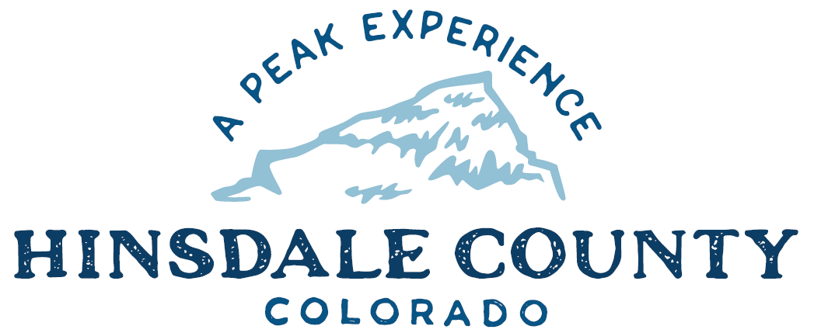

BOARD OF COUNTY COMMISSIONERS
WORKSHOP & MEETING
Coursey Annex, 311 N. Henson St., Lake City

Wednesday, November 18, 2020

You are invited to a Zoom meeting.
When: Nov 18, 2020 08:00 AM Mountain Time (US and Canada)

Register in advance for this meeting:
https://us02web.zoom.us/meeting/register/tZIudu2sqjMjHNCgYvYUiaKegkMGh1nV7mLq

If you are unable to register by email, join the meeting via phone by calling: 1 346 248 7799
Meeting ID: 863 1444 8964
Passcode: 265286

After registering, you will receive a confirmation email containing information about joining the meeting.

8:15 AM OPEN DISCUSSION

8:30 AM WORKSHOP (BOCC ONLY)

- Discuss Shepherd Property
- Discuss Hinsdale County, Town of Lake City 2021 & 2022 Law Enforcement Intergovernmental Agreement (IGA)
- Discuss Hinsdale County, Town of Lake City Building Enforcement IGA
- Discuss OHV Pilot Program
- Discuss Sale of Tax Lien Certificates Resolution – Treasurer Lori Lawrence
- Discuss Resiliency and Recovery Roadmaps Letter of Interest/Department of Local Affairs (DOLA) – Commissioner Borchers
- Discuss Lake San Cristobal Project – Commissioner Borchers
- Discuss El Pomar Grant Application for Lake San Cristobal Project – Commissioner Borchers
- Discuss Colorado Parks & Wildlife 2021-2022 OHV Trail Grant Application – Commissioner Borchers
- Discuss Tourism Recreation Management Committee - Commissioner Gutterman

CLOSE COMMISSIONER WORKSHOP
10 AM OPEN COMMISSIONER’S REGULAR MEETING

Pledge of Allegiance
Modifications to the Agenda
Approval of the Agenda

CITIZEN COMMENTS FROM THE FLOOR

REGULAR AGENDA

- Consider Sale of Tax Lien Certificates Resolution
- Consider Resiliency and Recovery Roadmaps Letter of Interest/DOLA
- Consider El Pomar Grant Application for Lake San Cristobal Project
- Consider Colorado Parks & Wildlife 2021-2022 OHV Trail Grant
- Consider Tourism Recreation Management Committee

ANY UNSCHEDULED BUSINESS
PRESENTATION OF BILLS TO BE PAID

11 AM WORKSHOP (BOCC & Board of Trustees BOT Combined)

- Discuss OHV Pilot Program
- Discuss Building Code Adoption
- Discuss Hinsdale County, Town of Lake City 2021 & 2022 Law Enforcement IGA
- Discuss Hinsdale County, Town of Lake City Building Enforcement IGA

Executive Session: An executive session of a personnel matter pursuant to C.R.S. 24-6-402(4)(f), to discuss the Road and Bridge Supervisor role with Don Menzies and not involving any specific employees who have requested discussion of the matter in open session; any member of this body or any elected official; the appointment of any person to fill an office of this body or of an elected official; or personnel policies that do not require the discussion of matters personal to particular employees.

ADJOURN

Times stated are approximate and the agenda may be modified as necessary at the discretion of the Board. The next Commissioner’s meeting is a workshop and regular meeting scheduled for Wednesday, December 9, 2020 unless otherwise noted at the Coursey Annex, 311 N. Henson Street, Lake City, CO 81235. Commissioner's workshop will begin at 8:15 AM and the regular meeting at 10:00 AM.

Two or more Hinsdale County Commissioners may virtually attend the Town of Lake City Board of Trustees Zoom Meeting on Wednesday, November 18, at 6 p.m.

