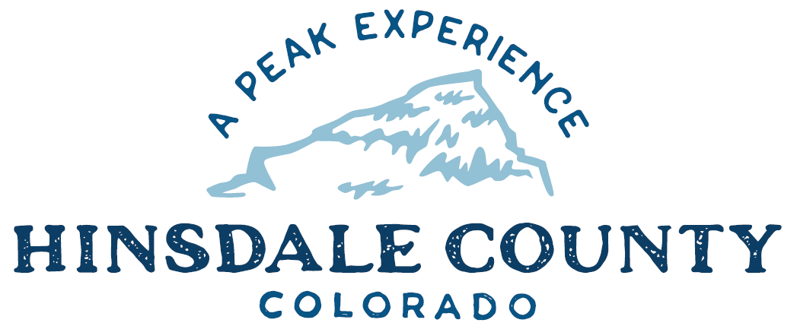

BOARD OF COUNTY COMMISSIONERS
WORKSHOP & MEETING
Coursey Annex, 311 N. Henson St., Lake City

Wednesday, November 30, 2022 – 8 a.m.
AGENDA

8 AM OPEN DISCUSSION

8:30 AM WORKSHOP

- Discuss Casualty Property Pool and Worker’s Comp Reports, Marilyn Wagner, County Technical Services, Inc.
- Discuss Ordinance Adopting the 2020 Edition of the Model Traffic Code
- Discuss Continuity of Government Plan
- Discuss Increasing Hinsdale County EMS Rates
- Discuss Designation of Snow Grooming CD for Groomer Replacement
- Discuss 2023 Agreement with GL Computer Service for Local Area Network (LAN) Management Support Services
- Discuss Grants Path
- Discuss Resolution Cancelling Uncollectable Possessory Interest Taxes that have been Delinquent for More than One Year
- Discuss Changes to the Hinsdale County Personnel Policy
- Discuss Jerry Gray Resignation as County Coroner
- Discuss Appointment of Lori Lawrence as Hinsdale County Coroner

CLOSE COMMISSIONER WORKSHOP

OPEN COMMISSIONER’S REGULAR MEETING

Pledge of Allegiance
Modifications to the Agenda
Approval of the Agenda

10 AM PUBLIC HEARING – Regarding Adoption of the 2020 Edition of the Model Traffic Code

CITIZEN COMMENTS FROM THE FLOOR

REGULAR AGENDA
- Consider Ordinance Adopting the 2020 Edition of the Model Traffic Code
- Consider Jerry Gray Resignation as County Coroner
- Consider Appointment of Lori Lawrence as Hinsdale County Coroner
- Consider Increasing Hinsdale County EMS Rates
- Consider 2023 Agreement with GL Computer Service for Local Area Network (LAN) Management Support Services
- Consider Resolution Cancelling Uncollectable Possessory Interest Taxes that have been Delinquent for More than One Year
- Consider Changes to the Hinsdale County Personnel Policy

PRESENTATION OF BILLS TO BE PAID

ADJOURN MEETING

1 PM RE-CONVENE WORKSHOP

- Discuss Solar Options for Hill 71 with Matt Feier, Gunnison County Electric Association, and Taylor Henderson, Outshine Energy

To attend this meeting via Zoom, register at the link below:
https://us02web.zoom.us/meeting/register/tZEucu-rrj8uHdOAhj-hylNwI8U6_Yq7ivQi

After registering, you will receive a confirmation email containing information about joining the meeting.

Times stated are approximate and the agenda may be modified as necessary at the discretion of the Board. The next Commissioner’s meeting is a workshop and meeting scheduled for Wednesday, December 7, 2022, unless otherwise noted at the Coursey Annex, 311 N. Henson Street, Lake City, CO 81235.

