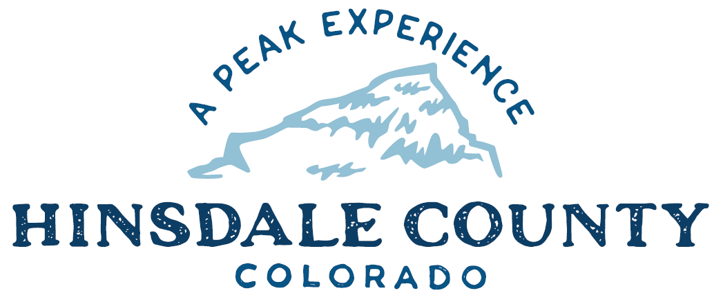

BOARD OF COUNTY COMMISSIONERS

WORKSHOP & MEETING
Coursey Annex, 311 Henson Street, Lake City

Wednesday, November 2, 2022 - 8 a.m.

8 AM OPEN DISCUSSION

8:30 AM WORKSHOP

- Discuss Transfer of 2012 Ford Van to Hinsdale County School District
- Discuss Termination of Current Agreement with Lake City Continental Divide Snowmobile Club
- Discuss Storage, Transportation, and Maintenance and Repairs Agreement with Lake City Continental Divide Snowmobile Club
- Discuss Work for Others Fees
- Discuss Recreation Policy
- Discuss Personnel Policy Updates
- Discuss Resolution to Honor and Recognize Veterans’ Day
- Discuss Resolution Authorizing Assessor to Settle Abatement Petitions of $10,000 or Less
- Discuss SCS Investment Properties LLC Abatement Hearing Date
- Discuss Intergovernmental Agreement (IGA) for County Coalition to Participate in the Conservation Team for Rio Grande Cutthroat Trout and Rio Grande Chub and Sucker
- Discuss Appointment of Amanda Hartman to West Regional Emergency Medical & Trauma Advisory Council (WRETAC)
- Discuss Draft Ordinance Adopting 2020 Model Traffic Code and Set Public Hearing Date
- Discuss Main Street Mini-grant Project Proposal for Retrofitting Historic Lamppost for Dark Skies
- Discuss Letter of Support for Lake Fork Valley Conservancy (LFVC) Dark Sky Certification Mentor Program Project

CLOSE COMMISSIONER WORKSHOP

OPEN COMMISSIONERS REGULAR MEETING

Pledge of Allegiance
Modifications to the Agenda
Approval of the Agenda
Approval of the Minutes

CITIZEN COMMENTS FROM THE FLOOR

10 AM REGULAR AGENDA

- Consider Transfer of 2012 Ford Van to Hinsdale County School District
- Consider Termination of Current Agreement with Lake City Continental Divide Snowmobile Club
- Consider Storage, Transportation, and Maintenance and Repairs Agreement with Lake City Continental Divide Snowmobile Club
- Consider Resolution to Honor and Recognize Veterans’ Day
- Consider Resolution Authorizing Assessor to Settle Abatement Petitions of $10,000 or Less
- Consider IGA for County Coalition to Participate in the Conservation Team for Rio Grande Cutthroat Trout and Rio Grande Chub and Sucker
- Consider Appointment of Amanda Hartman to WRETAC
- Consider Draft Ordinance Adopting 2020 Model Traffic Code and Set Public Hearing Date
- Consider Main Street Mini-grant Project Proposal for Retrofitting Historic Lamppost for Dark Skies
- Consider Letter of Support for LFVC Dark Sky Certification Mentor Program Project

PRESENTATION OF BILLS TO BE PAID

REPORTS:
Commissioners
Administration
Building Official
Road and Bridge
EMS Director
Emergency Manager
Sheriff

ADJOURN MEETING

- PM RE-CONVENE WORKSHOP

- Discuss Broadband Project Update with Michelle Haynes and Corey Bryndal, Region 10, and Justin Davis, Visionary Broadband

Register in advance for this meeting:
https://us02web.zoom.us/meeting/register/tZIkfuiuqDsuE9XB0ZDNd4rpUnUyq4THNCZV

After registering, you will receive a confirmation email containing information about joining the meeting.

Times stated are approximate and the agenda may be modified as necessary at the discretion of the Board. The next Commissioner’s meeting is a workshop and meeting scheduled for Wednesday, November 16, 2022, at the Commissioners’ Meeting Room, 311 Henson St., Lake City. The meeting will begin at 8 a.m.

Two or more Hinsdale County Commissioners may attend the Town of Lake City Board of Trustees Meeting on Wednesday, November 2, 2022, at 6 p.m.

