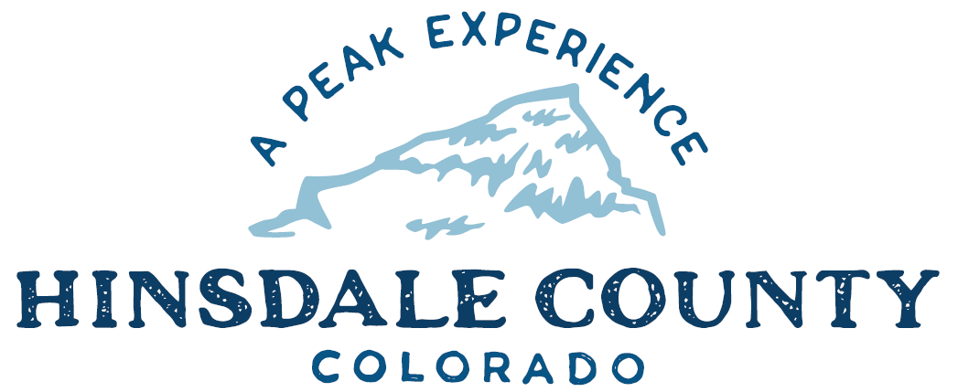

BOARD OF COUNTY COMMISSIONERS

WORKSHOP & MEETING
Coursey Annex, 311 Henson Street, Lake City

Wednesday, October 5, 2022 - 8 a.m.

8 AM OPEN DISCUSSION

8:30 AM WORKSHOP

- Discuss Hinsdale County School District Proposal for County Van
- Discuss Memorandum of Understanding (MOU) for Control of Confidential Data Appointing Lynn McNitt to Receive Sales Tax Information
- Discuss MOU for Control of Confidential Data Appointing Lynn McNitt to Receive Lodging Tax Information
- Discuss Upper Piedra Land Conveyance for Multi-Jurisdictional Facility/County Shop
- Discuss Ratification of Colorado Scenic Byways Letter of Support for Grant Application
- Discuss Amendment to OHV Ordinance
- Discuss Heritage and Trails Foundation Grant Application
- Discuss Wildlife Urban Interface Grant Application
- Discuss Assessor’s Annual Audit Report
CLOSE COMMISSIONER WORKSHOP

10 AM Abatement Hearing – SCS Generational Properties, LLC

EXECUTIVE SESSION: An executive session for a conference with the County Attorney for the purpose of receiving legal advice on specific legal questions pursuant to C.R.S. § 24-6-402(4)(b), as it relates to the October 5, 2022 abatement hearing.

OPEN COMMISSIONERS REGULAR MEETING

Pledge of Allegiance
Modifications to the Agenda
Approval of the Agenda
Approval of the Minutes

CITIZEN COMMENTS FROM THE FLOOR

REGULAR AGENDA

- Consider Possible Decision Regarding Abatement Hearing
- Consider Memorandum of Understanding (MOU) for Control of Confidential Data Appointing Lynn McNitt to Receive Sales Tax Information
- Consider MOU for Control of Confidential Data Appointing Lynn McNitt to Receive Lodging Tax Information
- Consider Ratification of Colorado Scenic Byways Letter of Support for Grant Application
- Consider Heritage and Trails Foundation Grant Application
- Consider Wildlife Urban Interface Grant Application
PRESENTATION OF BILLS TO BE PAID

REPORTS:
Commissioners
Administration
Building Official
Road and Bridge
EMS Director
Emergency Manager
Sheriff

11:30 AM EXECUTIVE SESSION: An executive session for the purpose of determining positions relative to matters that may be subject to negotiations, developing strategy for negotiations, and/or instructing negotiators pursuant to C.R.S. § 24-6-402(4)(e) as it relates to the legal action initiated by Norman Ragle.

- Appointment of a Hinsdale County Representative to Mediation for Legal Action Initiated by Norman Ragle.
ADJOURN MEETING

1 PM RE-CONVENE WORKSHOP

- Discuss Transportation Issues with Colorado Department of Transportation Regional Director Jason Smith

To attend this meeting via Zoom, register at the link below:
https://us02web.zoom.us/meeting/register/tZUrduitpjkqE9RjIp1Pm5_Ci57sC9kgh02j

After registering, you will receive a confirmation email containing information about joining the meeting.

Times stated are approximate and the agenda may be modified as necessary at the discretion of the Board. The next Commissioner’s meeting is a workshop and meeting scheduled for Wednesday, October 19, 2022, at the Commissioners’ Meeting Room, 311 Henson St., Lake City. The meeting will begin at 8 a.m.

Two or more Hinsdale County Commissioners may attend the Town of Lake City Board of Trustees Meeting on Wednesday, October 5, 2022, at 6 p.m.

