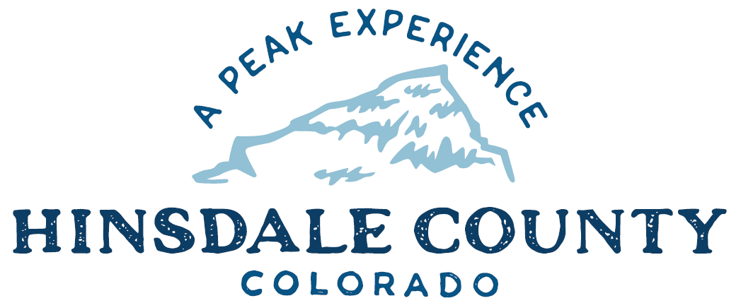

BOARD OF COUNTY COMMISSIONERS
WORKSHOP & MEETING
Coursey Annex, 311 N. Henson St., Lake City

Wednesday, October 19, 2022 – 8 a.m.
AGENDA

8 AM OPEN DISCUSSION

8:30 AM WORKSHOP

- Discuss Deer Lakes with Dayle Funka, District Ranger, Grand Mesa, Uncompahgre and Gunnison National Forests, and Brandon Diamond and Other Colorado Parks and Wildlife Representatives
- Discuss Search and Rescue Vehicle Needs
- Discuss Debris Mitigation Plan
- Discuss Hinsdale County Support of Gunnison Outdoor Resources Protection Act
- Discuss Snowmobile Trail Grooming
- Discuss Sheriff Office/Administration Building Next Steps
- Discuss X Field Services Contract for Transportation and Placement of Toilets
- Discuss Sales Quote for Road and Bridge Backhoe

CLOSE COMMISSIONER WORKSHOP

10 AM OPEN COMMISSIONER’S REGULAR MEETING

Pledge of Allegiance
Modifications to the Agenda
Approval of the Agenda

CITIZEN COMMENTS FROM THE FLOOR

REGULAR AGENDA

- Consider X Field Services Contract for Transportation and Placement of Toilets
- Consider Sales Quote for Road and Bridge Backhoe
TREASURER’S REPORT

PRESENTATION OF BILLS TO BE PAID

ADJOURN MEETING

Register in advance for this meeting:
https://us02web.zoom.us/meeting/register/tZ0pduqpqT4qGtS3r3QREmJFZF9v4OlzzWSU

After registering, you will receive a confirmation email containing information about joining the meeting.

Times stated are approximate and the agenda may be modified as necessary at the discretion of the Board. The next Commissioner’s meeting is a workshop and meeting scheduled for Wednesday, November 2, 2022, unless otherwise noted at the Coursey Annex, 311 N. Henson Street, Lake City, CO 81235.

Two or more Hinsdale County Commissioners may attend the Town of Lake City Board of Trustees Meeting on Wednesday, October 19, 2022, at 5:30 p.m.

