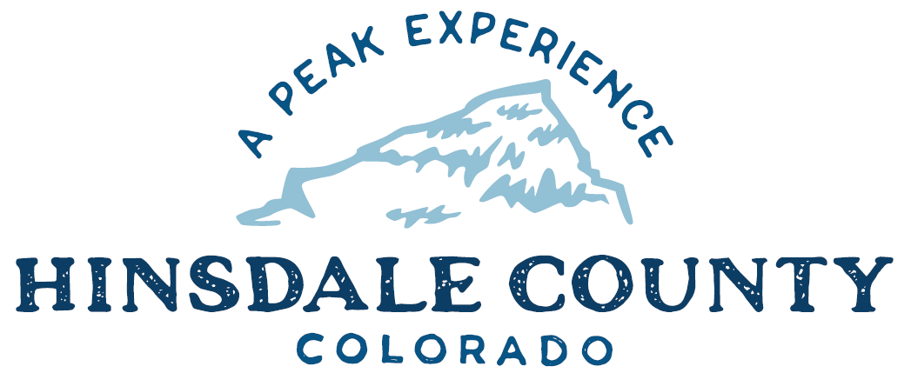

BOARD OF COUNTY COMMISSIONERS

WORKSHOP & MEETING
Coursey Annex, 311 Henson Street, Lake City

Wednesday, October 6, 2021 - 8 a.m.

Register in advance for this meeting:
https://us02web.zoom.us/meeting/register/tZ0sd-mupzMuGdT6xbq2ajgJ2T5szLcFbC3P

After registering, you will receive a confirmation email containing information about joining the meeting.
If attending by phone, call 346 248 7799
Meeting ID: 891 0069 8430
Passcode: 880645

Technical difficulties may occur during the meeting due to network limitations.

8 AM OPEN DISCUSSION

8:30 AM WORKSHOP

- Discuss Colorado Housing and Finance Authority (CHFA) Small Housing Innovation Program (SHIP) Workforce Housing Project Report
- Discuss All County Survey Services Agreement for Workforce Housing Project Location Survey
- Discuss 2020 Audit with Lisa Heumann, with Chadwick, Steinkirchner, Davis & Co
- Discuss Recreation Policy
- Discuss Agreement with Lake City Continental Divide Snowmobile Club for Snowmobile Trail Grooming
- Discuss Intergovernmental Agreement (IGA) with Archuleta County for Jail Services
- Discuss Amending Mt. Morris Lode Sale Contract to Extend Deadlines
- Discuss Process for Selling County Property
- Discuss Ratification of Colorado Department Public Health & Environment (CDPHE) Grant for Wupperman Campground Water System
- Discuss Ratification of Department of Local Affairs (DOLA) Grant for Search and Rescue Equipment and Training
- Discuss Memorandum of Understand (MOU) for Confidential Data – Sales Tax
- Discuss MOU for Confidential Data – Lodging Tax
- Discuss State of Colorado MOU for Opioid Settlement Funds.
- Discuss Southwest Colorado Opioid Regional Council IGA for Opioid Settlement Funds.
- Discuss Appointments to Southwest Colorado Opioid Regional Council
- Discuss Update of Transfer Station Price List
- Discuss Update on Organic Material Slash Dumping Program at Transfer Station
- Discuss Refund of Stryker Building Permit Application Fee
- Discuss Letter of Support for Equitable Solar Solutions to Julius Baer Foundation for Hill 71 Solar

CLOSE COMMISSIONER WORKSHOP

10 AM REGULAR MEETING

` Pledge of Allegiance
Modifications to the Agenda
Approval of the Agenda
Approval of the Minutes

CITIZEN COMMENTS FROM THE FLOOR

REGULAR AGENDA

- Consider All County Survey Services Agreement for Workforce Housing Project Location Survey
- Consider Agreement with Lake City Continental Divide Snowmobile Club for Snowmobile Trail Grooming
- Consider IGA with Archuleta County for Jail Services
- Consider Amending Mt. Morris Lode Sale Contract to Extend Deadlines
- Consider Ratification of CDPHE Grant for Wupperman Campground Water System
- Consider Ratification of DOLA Grant for Search and Rescue Equipment and Training
- Consider MOU for Confidential Data – Sales Tax
- Consider MOU for Confidential Data – Lodging Tax
- Consider State of Colorado MOU for Opioid Settlement Funds.
- Consider Southwest Colorado Opioid Regional Council IGA for Opioid Settlement Funds.
- Consider Appointments to Southwest Colorado Opioid Regional Council
- Consider Update of Transfer Station Price List
- Consider Refund of Stryker Building Permit Application Fee
- Consider Letter of Support for Equitable Solar Solutions to Julius Baer Foundation for Hill 71 Solar

ANY UNSCHEDULED BUSINESS
PRESENTATION OF BILLS TO BE PAID

REPORTS:
Commissioners
Administration
Building Official
Road and Bridge
EMS Director
Emergency Manager
Sheriff

EXECUTIVE SESSION - An executive session to discuss the potential sale of the Wee Care property pursuant to C.R.S. § 24-6-402(4)(a).

ADJOURN

BUDGET WORKSHOP #2

Times stated are approximate and the agenda may be modified as necessary at the discretion of the Board. The next Commissioner’s meeting is Commissioners scheduled for Wednesday, October 20, 2021, at the Commissioners’ Meeting Room, 311 Henson St., Lake City. The meeting will begin at 8 a.m.

Two or more Hinsdale County Commissioners may attend the Town of Lake City Board of Trustees Meeting on Wednesday, October 6, 2021, at 6 p.m.

