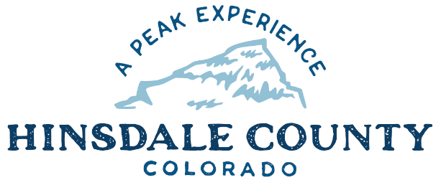
HINSDALE COUNTY

BOARD OF COUNTY COMMISSIONERS
WORKSHOP & MEETING
Coursey Annex, 311 North Henson St.
Lake City, CO

Wednesday, September 16, 2020
AGENDA

Sandy Hines is inviting you to a scheduled Zoom meeting.

When: Sep 16, 2020 08:00 AM Mountain Time (US and Canada)

Register in advance for this meeting:
https://us02web.zoom.us/meeting/register/tZwvcuipqT4oE9OKGMEjOU7S6NkSKgfhbtOk

After registering, you will receive a confirmation email containing information about joining the meeting.

Or call in +1 346 248 7799
Meeting ID: 882 5117 5297
Passcode: 566427
________________________________________________________________

8:15 AM OPEN DISCUSSION
- Slumgullion Inlet

8:30 AM WORKSHOP
- Discuss Friends of the River District – Colorado River District – Sue Hansen
- Discuss Conditions and Future Plans for County Road 30 – Interim Road and Bridge Supervisor Don Menzies
- Discuss Lake Fork Community Foundation Grant Application – First Responder Mental Health Class – EMS Director Buffy Witt
- Discuss 2020 Abstract of Assessment - Assessor, Luke de la Parra
- Discuss 2015 Building Code Adoption Process – Building Official Richard Kimball
- Discuss Trails Commission Recommendation for Appointment of John Paulus – Interim Administrator Sandy Hines
- Discuss Tourism Management Planning Group Update – Commissioner Gutterman
- Discuss Lake San Cristobal project including Grant Pathway – Commissioner Borchers
- Discuss Contract for Purchase of Lake San Cristobal Peninsula – Commissioner Borchers
- Discuss Observatory (TBD Name) – Commissioner Borchers
- Discuss Lake Fork Community Foundation Grant Application Observatory – Commissioner Borchers
- Discuss Great Outdoors Colorado (GOCO) Youth Corps Grant Application for Alpine Loop – Commissioner Borchers
- Discuss San Juan National Forest/Hinsdale County Sheriff Office Agreement Modification
- Discuss Great America’s Outdoors Act projects – Commissioner Borchers

CLOSE COMMISSIONER WORKSHOP

11 AM OPEN COMMISSIONER’S REGULAR MEETING

11:05 AM PROPANE SERVICE 2021 BID AWARD

Pledge of Allegiance
Modifications to the Agenda
Approval of the Agenda

CITIZEN COMMENTS FROM THE FLOOR

REGULAR AGENDA
- Propane Service 2021 Bid Award
- Consider Lake Fork Community Foundation Grant Application – First Responder Mental Health Class
- Consider 2020 Abstract of Assessment
- Consider Trails Commission Recommendation for Appointment of John Paulus
- Consider Contract for Purchase of Lake San Cristobal Peninsula
- Consider Lake Fork Community Foundation Grant Application - Observatory
- Consider San Juan National Forest/Hinsdale County Sheriff Office Agreement Modification
- Consider GOCO Youth Corps Grant Application for Alpine Loop

ANY UNSCHEDULED BUSINESS
Presentation of Bills to be Paid

ADJOURN

1:00 PM BUDGET WORKSHOP #2

Times stated are approximate and the agenda may be modified as necessary at the discretion of the Board. The next Commissioner’s meeting is a workshop and regular meeting scheduled for Wednesday, October 7, 2020 unless otherwise noted at the Coursey Annex, 311 N. Henson Street, Lake City, CO 81235. Commissioner's workshop will begin at 8:30 AM and the regular meeting at 10:00 AM.

Two or more Hinsdale County Commissioners may virtually attend the Town of Lake City Board of Trustees Zoom Meeting on Wednesday, September 16, at 6 p.m.

