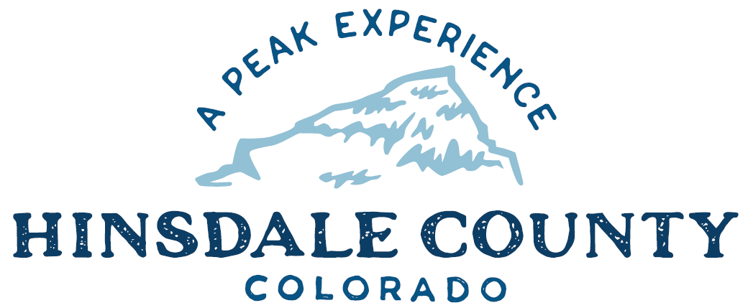

BOARD OF COUNTY COMMISSIONERS

WORKSHOP & MEETING
Coursey Annex, 311 Henson Street, Lake City

Wednesday, August 4, 2021 - 8 a.m.

Register in advance for this meeting:
https://us02web.zoom.us/meeting/register/tZIuc-2hqj0iE9z52yWgE2J6s6EZni8Hn0zg

After registering, you will receive a confirmation email containing information about joining the meeting.

If attending by phone, call 346 248 7799
Meeting ID: 863 4494 6898
Passcode: 747369

Technical difficulties may occur during the meeting due to network limitations.

8 AM OPEN DISCUSSION

8:30 AM WORKSHOP

- Discuss Snowmobile Trail Grooming Agreement with Lake City Continental Divide Snowmobile Club
- Discuss Lake San Cristobal Update
- Discuss Main Street: Open for Business Grant Application
- Discuss Contract for Sale of Mount Morris Lode
- Discuss 2020 Audit
- Discuss Revised Electronic Recording Technology Board (ERTB) Grant Agreement
- Discuss Amendment Agreement with Gunnison County Electric Association (GCEA) for Line Extension Agreement
- Discuss Agreement Concerning Election Services between Hinsdale County Clerk and Hinsdale County School District RE-1
- Discuss Road Project Agreement with Grand Mesa, Uncompahgre and Gunnison (GMUG) National Forest for Deer Lakes Road Reconstruction
- Discuss Response to Pagosa Springs Sun Article
CLOSE COMMISSIONER WORKSHOP

10 AM REGULAR MEETING

Pledge of Allegiance
Modifications to the Agenda
Approval of the Agenda
Approval of the Minutes

CITIZEN COMMENTS FROM THE FLOOR

REGULAR AGENDA

- Consider Main Street: Open for Business Grant Application
- Consider Revised ERTB Grant Agreement
- Consider Amendment Agreement to GCEA Line Extension Contract
- Consider Agreement Concerning Election Services between Hinsdale County Clerk and Hinsdale County School District RE-1
- Consider Road Project Agreement with GMUG National Forest for Deer Lakes Road Reconstruction
- Consider Response to Pagosa Springs Sun Article

ANY UNSCHEDULED BUSINESS
PRESENTATION OF BILLS TO BE PAID

REPORTS:
Commissioners
Administration
Building Official
Road and Bridge
EMS Director
Emergency Manager
Sheriff

EXECUTIVE SESSION - An executive session for a conference with the County Attorney for the purpose of receiving legal advice on specific legal questions pursuant to C.R.S. § 24-6-402(4)(b) as it relates to litigation commenced against the County by Norman Ragle.

ADJOURN

Times stated are approximate and the agenda may be modified as necessary at the discretion of the Board. The next Commissioner’s meeting is a joint meeting with Mineral County Commissioners scheduled for Wednesday, August 25, 2021, at 39284 Hwy 149, Creede, CO. The meeting will begin at 10 a.m.

Two or more Hinsdale County Commissioners may attend the Town of Lake City Board of Trustees Meeting on Wednesday, August 4, 2021, at 6 p.m.

