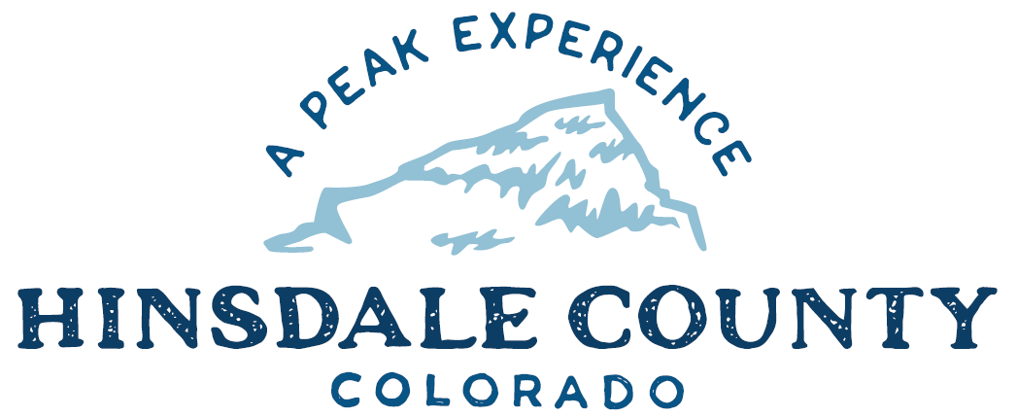

BOARD OF COUNTY COMMISSIONERS
WORKSHOP & MEETING
Coursey Annex, 311 N. Henson St., Lake City

Wednesday, May 19, 2021 – 8 a.m.

AGENDA

Register in advance for this meeting:
https://us02web.zoom.us/meeting/register/tZMpd-2vqzkiHdWSC-jKPLxNvLpjQRAzpGyQ
Meeting ID: 874 0475 2871
Passcode: 097085

After registering, you will receive a confirmation email containing information about joining the meeting. If attending by phone, call 346 248 7799

Technical difficulties may occur during the meeting due to network limitations.

8 AM OPEN DISCUSSION

8:30 AM WORKSHOP
- Discuss Colorado Department of Transportation (CDOT) Safety Circuit Rider Program – James Nall
- Discuss Ute-Ulay Update – Commissioner Kristie Borchers
- Discuss Sheriff Office Space Expansion – Commissioner Greg Levine
- Discuss Lake San Cristobal Project Update – Commissioner Kristie Borchers
- Discuss Anschutz Family Foundation Letter of Inquiry for Peninsula Project – Commissioner Kristie Borchers
- Discuss Gunnison Basin Forest Health Collaboration - Commissioner Kristie Borchers
- Discuss Letter of Support for Ouray County's Ouray Recreation & Conservation Alliance (ORCA) Grant Application - Commissioner Kristie Borchers
- Discuss Car 211State Historic Fund Letter of Significance and Support – Commissioner Kristie Borchers
- Discussion Gunnison Basin Weed Commission Intergovernmental Agreement for Noxious Weed Management – Commissioner Robert Hurd
- Discuss Secure Rural Schools Fund Resolution – Finance Director Lynn McNitt
- Discuss Electronic Recording Technology Board Grant Agreement – Clerk Joan Roberts
- Discuss Sheriff Office, Forest Service Cooperative Law Enforcement Annual Operating Plans - Grand Mesa, Uncompahgre & Gunnison (GMUG), Rio Grande, and San Juan National Forests
- Discuss Resolution Opposing Colorado Initiative #16
- Discuss Grants Path – Finance Director Lynn McNitt
- Discuss Budget Update – Finance Director Lynn McNitt

CLOSE COMMISSIONER WORKSHOP

10 AM OPEN COMMISSIONER’S REGULAR MEETING
Pledge of Allegiance
Modifications to the Agenda
Approval of the Agenda

CITIZEN COMMENTS FROM THE FLOOR

REGULAR AGENDA

- Consider Letter of Inquiry to Anschutz Family Foundation
- Consider Letter of Support for Ouray County's Ouray Recreation & Conservation Alliance (ORCA) Grant Application
- Consider Car 211 State Historic Fund Letter of Significance and Support
- Consider Gunnison Basin Weed Commission Intergovernmental Agreement for Noxious Weed Management
- Consider Secure Rural Schools Fund Resolution
- Consider Electronic Recording Technology Board Grant Agreement
- Ratify Sheriff Office, Forest Service Cooperative Law Enforcement Annual Operating Plans - GMUG, Rio Grande, and San Juan National Forests
- Consider Resolution Opposing Colorado Initiative #16

ANY UNSCHEDULED BUSINESS
PRESENTATION OF BILLS TO BE PAID

ADJOURN MEETING

1 PM RECONVENE WORKSHOP

16. Discuss Project Roadmaps

Times stated are approximate and the agenda may be modified as necessary at the discretion of the Board. The next Commissioner’s meeting is a workshop and meeting scheduled for Wednesday, June 2, 2021, unless otherwise noted at the Coursey Annex, 311 N. Henson Street, Lake City, CO 81235.
Two or more Hinsdale County Commissioners may virtually attend the Town of Lake City Board of Trustees Zoom Meeting on Wednesday, May 19, at 6 p.m.

