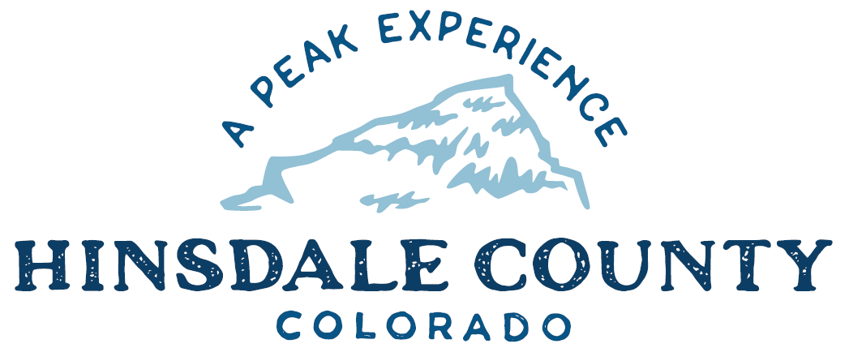

BOARD OF COUNTY COMMISSIONERS

WORKSHOP & MEETING
Coursey Annex, 311 Henson Street, Lake City

Wednesday, April 7, 2021 - 8 a.m.

Register in advance for this meeting:
https://us02web.zoom.us/meeting/register/tZAuceyprDotGNQ7zp3THl55DPP6QYgMYjgx

After registering, you will receive a confirmation email containing information about joining the meeting.

If attending by phone, call 346 248 7799

Meeting ID: 843 6512 1720
Passcode: 267736

Technical difficulties may occur during the meeting due to network limitations.

8 AM OPEN DISCUSSION

8:30 AM WORKSHOP

- Discuss Update on County Road 30 project – R/B Supervisor Don Menzies
- Discuss Rocky Mountain Resource Advisory Committee (RAC) Statement of Support
- Discuss Process for Selling or Leasing County Land Not Under Covenant
- Discuss Main Street Mini-Grant 2021 Project – Lake City DIRT Executive Director Kristie Borchers
- Discuss Support Letter for Good Samaritan Legislation – Administrator Sandy Hines
- Discuss Amended Ordinance Regulating Use of Off-Highway Vehicles on Public Roads in Unincorporated Hinsdale County
- Discuss Campground Fees/Recreation Policy – Administrator Sandy Hines
- Discuss Process to Address Wake Control on Lake San Cristobal – Attorney Michael O’Loughlin
- Discuss Hill 71 Leases (Simply Broadband, Visionary Communications) – Attorney Michael O’Loughlin
- Discuss Memorandum of Agreement, Hidden Treasure Dam – Commissioner Kristie Borchers
- Discuss Budget Update – Finance Officer Lynn McNitt

10 AM REGULAR MEETING

Pledge of Allegiance
Modifications to the Agenda
Approval of the Agenda
Approval of the Minutes

CITIZEN COMMENTS FROM THE FLOOR

- Consider Rocky Mountain RAC Statement of Support
- Consider Main Street Mini-Grant 2021 Project
- Consider Support Letter for Good Samaritan Legislation
- Consider Amended Ordinance Regulating Use of Off-Highway Vehicles on Public Roads in Unincorporated Hinsdale County

ANY UNSCHEDULED BUSINESS
PRESENTATION OF BILLS TO BE PAID

REPORTS:
Commissioner Reports
Administration Report
Building Official Report
Road and Bridge Report
EMS Director
Emergency Manager
Sheriff

ADJOURN

Times stated are approximate and the agenda may be modified as necessary at the discretion of the Board. The next Commissioner’s meeting is a workshop and regular meeting scheduled for Wednesday, April 21, 2021 unless otherwise noted at the Coursey Annex, 311 N. Henson Street, Lake City, CO 81235. Commissioner's workshop will begin at 8:30 AM and the regular meeting at 10:00 AM.

Two or more Hinsdale County Commissioners may virtually attend the Town of Lake City Board of Trustees Zoom Meeting on Wednesday, April 7, 2021, at 6 p.m.

