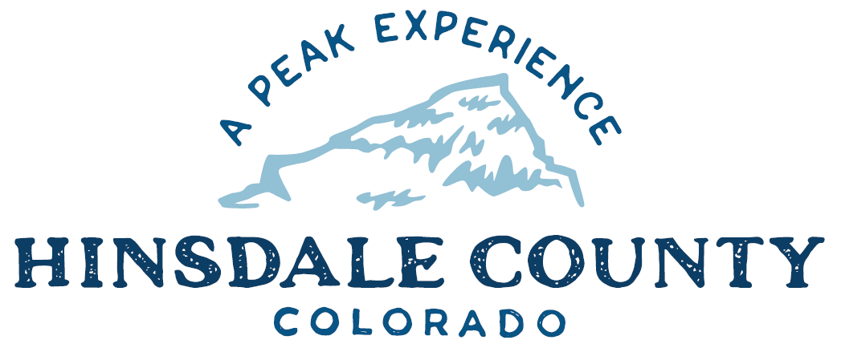

BOARD OF COUNTY COMMISSIONERS (BOCC) WORKSHOP & MEETING
COURSEY ANNEX, 311 N. HENSON ST., LAKE CITY

Wednesday, March 3, 2021

AGENDA

Register in advance for this meeting:
https://us02web.zoom.us/meeting/register/tZYsfuyoqz4tEtbQdbPmOD1VMzzOGi4DGb7K

After registering, you will receive a confirmation email containing information about joining the meeting.

If attending by phone, call 346 248 7799

Meeting ID: 821 9505 5782
Passcode: 106555

Technical difficulties may occur during the meeting due to network limitations.

8:15 AM OPEN DISCUSSION

8:30 AM WORKSHOP (BOCC ONLY)

- Discussion with Joni Reynolds, Public Health Director, Gunnison/Hinsdale County Health and Human Services
- Discussion with Sonja Chavez, General Manager, Upper Gunnison River Water Conservancy District
- Discuss Resource Advisory Council (RAC) Funding – Commissioner Kristie Borchers
- Discuss Hill 71 Lease Fees – Administrator Sandy Hines
- Discuss July 4 Fireworks – Commissioner Greg Levine
- Discuss Landmark Sign Project – Lake City DIRT Executive Director Kristie Borchers
- Discuss Shepherd Property Easement – Administrator Sandy Hines
- Discuss Gates Family Foundation Grant for Peninsula Infrastructure – Commissioner Kristie Borchers
- Discuss Don Menzies Employment Contract for Road and Bridge Supervisor/Shop Foreman – Administrator Sandy Hines
- Discuss Finance Director Lynn McNitt Employment Contract – Administrator Sandy Hines
- Discuss Liquor License Renewal, Sportsman’s Campground – Clerk Joan Roberts

10 AM REGULAR MEETING

Pledge of Allegiance
Modifications to the Agenda
Approval of the Agenda
Approval of the Minutes

CITIZEN COMMENTS FROM THE FLOOR

- Consider Gates Family Foundation Grant Application
- Consider Don Menzies Employment Contract for Road and Bridge Supervisor/Shop Foreman
- Consider Lynn McNitt Employment Contract
- Consider Liquor License Renewal, Sportsman’s Campground

ANY UNSCHEDULED BUSINESS
PRESENTATION OF BILLS TO BE PAID

REPORTS:
Commissioner Reports
Administration Report
Building Official Report
Road and Bridge Report
EMS Director
Emergency Manager
Sheriff

11 AM WORKSHOP (BOCC & Board of Trustees BOT Combined)

- Discuss Silver Thread Public Health District Report – Director Tara Hardy
- Discuss OHV Pilot Program
- Discuss Summer Visitor Trash Options
- Discuss July 4 Fireworks
- Discuss Emergency Management – Fire/Flood season preparation

CLOSE JOINT WORKSHOP
12. Work Session: Communications Roadmap, Commissioner Greg Levine

ADJOURN

Times stated are approximate and the agenda may be modified as necessary at the discretion of the Board. The next Commissioner’s meeting is a workshop and regular meeting scheduled for Wednesday, March 17, 2021 unless otherwise noted at the Coursey Annex, 311 N. Henson Street, Lake City, CO 81235. Commissioner's workshop will begin at 8:30 AM and the regular meeting at 10:00 AM.

Two or more Hinsdale County Commissioners may virtually attend the Town of Lake City Board of Trustees Zoom Meeting on Wednesday, March 3, 2021, at 6 p.m.

