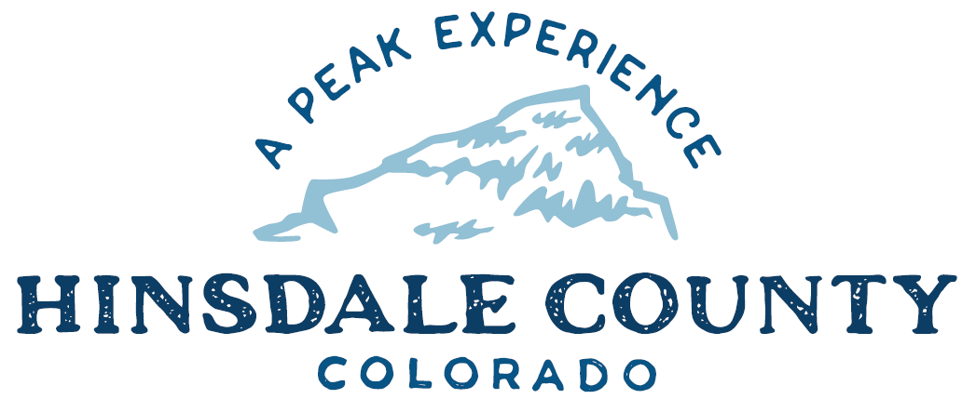

BOARD OF COUNTY COMMISSIONERS
WORKSHOP & MEETING
Coursey Annex, 311 N. Henson St., Lake City

Wednesday, February 17, 2021 - 8:15 a.m.

AGENDA

Register in advance for this Zoom meeting:
https://us02web.zoom.us/meeting/register/tZIsdu2hpzgsGNeWkk7GAvwNSVcO9WbgUzE4

After registering, you will receive a confirmation email containing information about joining the meeting.

If attending by phone, call 346 248 7799

Meeting ID: 861 1499 3623
Passcode: 295104

Technical difficulties may occur during the meeting due to network limitations.

8:15 AM OPEN DISCUSSION

8:30 AM WORKSHOP

- Discuss Lake San Cristobal Peninsula Project Update – Commissioner Kristie Borchers
- Discuss State Historic Fund Supplemental Funding Request Property Owner Letter for FS Road 520 Interpretive Signs – Commissioner Kristie Borchers
- Discuss Colorado Opportunity Scholarship Initiative (COSI) Participation for Western Colorado University – Administrator Sandy Hines
- Discuss Professional Services Agreement with Digitcom Electronics, Hill 71 Radio Technician – Commissioner Robert Hurd
- Discuss Equitable Solar Solutions (ESS) Letter of Support for Colorado Waste Diversion Grant – Administrator Sandy Hines
- Discuss New Admin/SO Building – Commissioner Kristie Borchers
- Discuss 2020 Highway Users Tax Fund (HUTF) Report to Colorado Department of Transportation (CDOT) – Finance Director Lynn McNitt
- Discuss RESOLUTION Setting 2021 County Mileage Reimbursement Rate – Administrator Sandy Hines
- Discuss Colorado Parks and Wildlife 2021 Impact Assistance Grant – Finance Director Lynn McNitt
- Discuss County Position on State Wolf Re-introduction Plan – Commissioner Greg Levine
- Discuss Budget Update – Finance Director Lynn McNitt
- Discuss Letter of Support for Lake Fork Valley Conservancy’s (LFVC) Malter Creek Restoration Design and Slumgullion Earthflow Assessment Grant Proposals – LFVC Director Camille Richard
CLOSE COMMISSIONER WORKSHOP

10 AM OPEN COMMISSIONER’S REGULAR MEETING
Pledge of Allegiance
Modifications to the Agenda
Approval of the Agenda

CITIZEN COMMENTS FROM THE FLOOR

REGULAR AGENDA

- Consider State Historic Fund Supplemental Funding Request Property Owner Letter for FS Road 520 Interpretive Signs
- Consider COSI Participation for Western Colorado University
- Consider Professional Services Agreement with Digitcom Electronics, Hill 71 Radio
- Consider ESS Letter of Support for Colorado Waste Diversion Grant
- Consider 2020 HUTF Report to CDOT
- Consider RESOLUTION Setting 2021 County Mileage Reimbursement Rate
- Consider Colorado Parks and Wildlife 2021 Impact Assistance Grant
- Consider Letter of Support for Lake Fork Valley Conservancy’s (LFVC) Malter Creek Restoration Design and Slumgullion Earthflow Assessment Grant Proposals

ANY UNSCHEDULED BUSINESS
PRESENTATION OF BILLS TO BE PAID

EXECUTIVE SESSION: Executive session of a personnel matter pursuant to C.R.S. 24-6-402(4)(f), to discuss the Road and Bridge Supervisor role with Don Menzies and not involving any specific employees who have requested discussion of the matter in open session; any member of this body or any elected official; the appointment of any person to fill an office of this body or of an elected official; or personnel policies that do not require the discussion of matters personal to particular employees.

EXECUTIVE SESSION: Executive session for the purposes of determining positions relative to matters that may be subject to negotiations, developing strategy for negotiations, and/or instructing negotiators pursuant to Section 24-6-402(4)(e), Colorado Revised Statutes, as it relates to the EEOC complaint and related claims by Norman Ragle against Hinsdale County.

9. Consider Response to Norman Ragle Settlement Offer for EEOC Complaint

ADJOURN MEETING

Times stated are approximate and the agenda may be modified as necessary at the discretion of the Board. The next Commissioner’s meeting is a workshop and regular meeting scheduled for Wednesday, March 3, 2021, unless otherwise noted at the Coursey Annex, 311 N. Henson Street, Lake City, CO 81235. Commissioner's workshop will begin at 8:30 AM and the regular meeting at 10:00 AM.
Two or more Hinsdale County Commissioners may virtually attend the Town of Lake City Board of Trustees Zoom Meeting on Wednesday, February 17, at 6 p.m.

