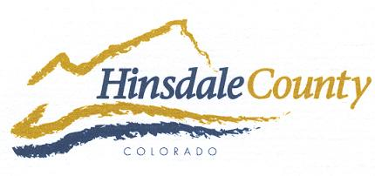

HINSDALE COUNTY
BOARD OF COUNTY COMMISSIONERS

THURSDAY, OCTOBER 4, 2018 – 7:00 PM
OHV SPECIAL MEETING

THE HINSDALE BOARD OF COUNTY COMMISSIONERS, TOWN OF LAKE CITY MAYOR AND BOARD OF TRUSTEES, ALPINE RANGER, AND SHERIFF ARE ALL INVITED TO PARTICIPATE IN A SPECIAL MEETING TO HEAR PUBLIC COMMENTS ON THE STATUS OF OHVs IN UNINCORPORATED HINSDALE COUNTY.

CITIZENS WHO CHOOSE TO SPEAK WILL BE GIVEN ONE TURN FOR TWO MINUTES EACH (SIGN UP SHEET AND TIMER PROVIDED). SPEAKERS SHOULD AVOID ANECDOTAL INFORMATION, HAVE RESPECT FOR OTHER OPINIONS, USE RESPECTFUL RHETORIC, AND FOCUS ON ISSUES…NOT PEOPLE. IF UNABLE TO APPEAR IN PERSON, EMAIL RESPONSES MAY BE SUBMITTED TO:

ADMINISTRATOR@HINSDALECOUNTYCOLORADO.US

THE PUBLIC FORUM WILL BE HELD AT 7:00 PM ON THURSDAY, OCTOBER 4, 2018 AT
THE LAKE CITY ARMORY
230 BLUFF STREET, LAKE CITY

